Regional Information Report No. 1J24-XX

Northern Southeast Inside Subdistrict Sablefish Management Plan and Stock Assessment for 2024

by

Philip Joy

and

Rhea Ehresmann

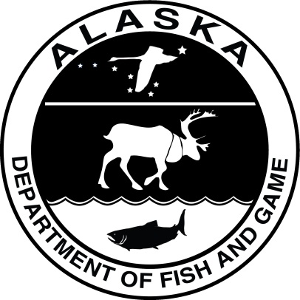

August 2024

Alaska Department of Fish and Game Divisions of Commercial Fisheries

Symbols and Abbreviations

The following symbols and abbreviations, and others approved for the Système International d'Unités (SI), are used without definition in the following reports by the Divisions of Sport Fish and of Commercial Fisheries: Fishery Manuscripts, Fishery Data Series Reports, Fishery Management Reports, and Special Publications. All others, including deviations from definitions listed below, are noted in the text at first mention, as well as in the titles or footnotes of tables, and in figure or figure captions.

**Weights and measures (metric)**

centimeter cm

deciliter dL

gram g

hectare ha

kilogram kg

kilometer km

liter L

meter m

milliliter mL

millimeter mm

**Weights and measures (English)**

cubic feet per second ft3/s

foot ft

gallon gal

inch in

mile mi

nautical mile nmi

ounce oz

pound lb

quart qt

yard yd

**Time and temperature**

day d

degrees Celsius °C

degrees Fahrenheit °F

degrees kelvin K

hour h

minute min

second s

**Physics and chemistry**

all atomic symbols

alternating current AC

ampere A

calorie cal

direct current DC

hertz Hz

horsepower hp

hydrogen ion activity pH

(negative log of)

parts per million ppm

parts per thousand ppt,

‰

volts V

watts W

**General**

Alaska Administrative

Code AAC

all commonly accepted

abbreviations e.g., Mr., Mrs., AM, PM, etc.

all commonly accepted

professional titles e.g., Dr., Ph.D.,

R.N., etc.

at @

compass directions:

east E

north N

south S

west W

copyright ©

corporate suffixes:

Company Co.

Corporation Corp.

Incorporated Inc.

Limited Ltd.

District of Columbia D.C.

et alii (and others) et al.

et cetera (and so forth) etc.

exempli gratia

(for example) e.g.

Federal Information

Code FIC

id est (that is) i.e.

latitude or longitude lat or long

monetary symbols

(U.S.) $, ¢

months (tables and

figures): first three

letters Jan,...,Dec

registered trademark ®

trademark ™

United States

(adjective) U.S.

United States of

America (noun) USA

U.S.C. United States Code

U.S. state use two-letter abbreviations (e.g., AK, WA)

**Mathematics, statistics**

*all standard mathematical*

*signs, symbols and*

*abbreviations*

alternate hypothesis HA

base of natural logarithm *e*

catch per unit effort CPUE

coefficient of variation CV

common test statistics (F, t, χ2, etc.)

confidence interval CI

correlation coefficient

(multiple) R

correlation coefficient

(simple) r

covariance cov

degree (angular) °

degrees of freedom df

expected value *E*

greater than >

greater than or equal to ≥

harvest per unit effort HPUE

less than <

less than or equal to ≤

logarithm (natural) ln

logarithm (base 10) log

logarithm (specify base) log2, etc.

minute (angular) ′

not significant NS

null hypothesis HO

percent %

probability P

probability of a type I error

(rejection of the null

hypothesis when true) α

probability of a type II error

(acceptance of the null

hypothesis when false) β

second (angular) ″

standard deviation SD

standard error SE

variance

population Var

sample var

Regional Information report XXX-XX

NORTHERN SOUTHEAST INSIDE SUBDISTRICT SABLEFISH management plan and Stock Assessment for 2024

by

Philip Joy

Alaska Department of Fish and Game, Division of Commercial Fisheries, Juneau

and

Rhea Ehresmann

Alaska Department of Fish and Game, Division of Commercial Fisheries, Sitka

Alaska Department of Fish and Game  
Division of Commercial Fisheries  
802 3rd, Douglas, Alaska, 99824-0020

August 2024

The Regional Information Report Series was established in 1987 and was redefined in 2007 to meet the Division of Commercial Fisheries regional need for publishing and archiving information such as area management plans, budgetary information, staff comments and opinions to Alaska Board of Fisheries proposals, interim or preliminary data and grant agency reports, special meeting or minor workshop results and other regional information not generally reported elsewhere. Reports in this series may contain raw data and preliminary results. Reports in this series receive varying degrees of regional, biometric and editorial review; information in this series may be subsequently finalized and published in a different department reporting series or in the formal literature. Please contact the author or the Division of Commercial Fisheries if in doubt of the level of review or preliminary nature of the data reported. Regional Information Reports are available through the Alaska State Library and on the Internet at: <http://www.adfg.alaska.gov/sf/publications/>.

Product names used in this publication are included for completeness and do not constitute product endorsement. The Alaska Department of Fish and Game does not endorse or recommend any specific company or their products.

Philip Joy

Alaska Department of Fish and Game, Division of Commercial Fisheries,

1255 W. 8th Street, Juneau, AK 99801, USA

and

Rhea Ehresmann

Alaska Department of Fish and Game, Division of Commercial Fisheries,

304 Lake Street, Room 103, Sitka, AK 99835, USA

This document should be cited as follows:

Joy, P. and R. Ehresmann. 2024. Northern Southeast Inside Subdistrict sablefish management plan and stock assessment for 2024. Alaska Department of Fish and Game, Division of Commercial Fisheries, Regional Information Report 1J24-XX, Douglas.

The Alaska Department of Fish and Game (ADF&G) administers all programs and activities free from discrimination based on race, color, national origin, age, sex, religion, marital status, pregnancy, parenthood, or disability. The department administers all programs and activities in compliance with Title VI of the Civil Rights Act of 1964, Section 504 of the Rehabilitation Act of 1973, Title II of the Americans with Disabilities Act (ADA) of 1990, the Age Discrimination Act of 1975, and Title IX of the Education Amendments of 1972.

**If you believe you have been discriminated against in any program, activity, or facility please write:**

ADF&G ADA Coordinator, P.O. Box 115526, Juneau, AK 99811-5526

U.S. Fish and Wildlife Service, 4401 N. Fairfax Drive, MS 2042, Arlington, VA 22203

Office of Equal Opportunity, U.S. Department of the Interior, 1849 C Street NW MS 5230, Washington DC 20240

**The department’s ADA Coordinator can be reached via phone at the following numbers:**

(VOICE) 907-465-6077, (Statewide Telecommunication Device for the Deaf) 1-800-478-3648,

(Juneau TDD) 907-465-3646, or (FAX) 907-465-6078

**For information on alternative formats and questions on this publication, please contact:**

ADF&G, Division of Sport Fish, Research and Technical Services, 333 Raspberry Rd, Anchorage AK 99518 (907) 267-2375

TABLE OF CONTENTS

Page

LIST OF TABLES ii

LIST OF FIGURES ii

abstract 5

Introduction 5

2024 Sablefish management plan 7

Annual Harvest Objective Determination 7

Bycatch mortality in the halibut fishery 7

ADF&G longline survey removals 7

Sport fish harvest (guided and unguided) 7

Mortality from fishery deadloss 8

Personal use and subsistence harvest 8

Regulations 8

Registration and logbook requirements 8

Tagged sablefish 8

Sablefish possession and landing requirements 9

Fish ticket requirements 9

Bycatch allowances for other species 9

Sablefish live market 10

Prohibitions 10

2023 Sablefish Stock Assessment and 2024 RECOMMENDED ABC Determination 10

Changes to the 2023 NSEI Assessment Relative to 2022 13

ACKNOWLEDGEMENTS 29

REFERENCES CITED 30

Tables AND FIGURES 32

# LIST OF TABLES

Table Page

Table 1.–Annual harvest objective (round lb), equal quota share (EQS; round lb), reported harvest (round lb), exvessel value, number of permits, and effort (days) for the directed commercial Northern Southeast Inside (NSEI) Subdistrict sablefish fishery, 1985–2024. The EQS program was implemented in 1994. 33

Table 2.–Summary of key assessment results used to inform management in 2023 and 2024. This table includes the estimates of projected total biomass (sablefish aged 2 years and above) and female spawning stock biomass, estimated biological reference points of unfished female spawning biomass *()*, female spawning biomass at 50% of unfished levels *()*, and the maximum target fishing mortality of . Additional values include the maximum permissible Acceptable Biological Catch (max ABC) defined by , the estimates of mortality from fishery releases that would result under max ABC and a discard mortality rate of 0.16, and the recommended ABC under the max 15% change management procedure. 34

Table 3.–Decrement types and amounts, 2019–2024. Estimated catch is in round pounds of sablefish. 35

Table 4.–A comparison for biological reference points from candidate models in the 2023 assessment. Model v23 and v24 could not converge without the addition of additional time blocks in the selectivity parameters so only those models are shown here. Model v23 with the third survey time block starting in 2017 is the model used in this year’s assessment. 36

Table 5.–Variable definitions for the statistical catch-at-age model. 37

Table 6.–A summary of data inputs to the mark-recapture models, including total individuals tagged (*K*), the total number of tags remaining once size selectivity is accounted for (*K0*), tags not available to the longline survey or fishery (captured in other fisheries or outside Chatham, *D0*), recaptured individuals in the longline survey and fishery (*ksrv* and *kfsh*), number of sampled individuals in the longline survey and fishery (*nsrv* and *nfsh*), tags not available to the fishery (captured outside Chatham or in other fisheries during the survey, *Dsrv*, and tags recaptured in other fisheries or outside Chatham during the fishery (*Dfsh*) for years with a tagging survey, 2005–2022. There was no mark-recapture experiment in 2023. 40

Table 7.–Assumed selectivity parameters for the fishery before the Equal Quota Share program started in 1994 (pre-EQS), the fishery since the implementation of EQS for females and males when it was completely longline (1995–2021) and the fishery when it was a mix of longline and pot gear (2022–2023). These parameters estimates were borrowed from the Federal stock assessment, where the Federal derby fishery and IFQ fishery were assumed to represent pre-EQS and EQS NSEI fisheries. 41

Table 8.–Parameter estimates from the statistical catch-at-age model. Estimates of recruitment, initial numbers-at-age, and fishing mortality deviations were excluded for brevity. 42

Table 9.–Negative likelihood (NLL) values and percent of each component to the total likelihood (% of NLL). The data likelihood is the sum of all likelihood contributions from data. The difference between the total likelihood and the data likelihood is the contribution of penalized likelihoods, including recruitment and fishing mortality. 43

# LIST OF FIGURES

Figure Page

Figure 1.–Northern Southeast Inside (NSEI) and Southern Southeast Inside (SSEI) Subdistricts including restricted waters of Glacier Bay National Park and Preserve and Annette Islands Reserve. 44

Figure 2.–Catch, landings by port, and ex-vessel value for Northern Southeast Inside (NSEI) Subdistrict commercial sablefish 1985–2023. 45

Figure 3.–Estimated catch in the Northern Southeast Inside (NSEI) Subdistrict fishery from 2000–2023 and the relationship to *F40, F50* and *F60* (*Fspr*), the fishing mortality that results in a spawner-per-recruit (SPR) of 40, 50 and 60% of the population’s virgin state in model v23. 46

Figure 4.–A summary of the available data sources in the Northern Southeast Inside (NSEI) Subdistrict by year. 47

Figure 5.–A comparison of the mean length and age in the longline and pot fishery and longline survey since 1997 for male and female sablefish in the Northern Southeast Inside (NSEI) Subdistrict. The pot fishery is only included for 2022 and 2023 when pot gear became a legal gear type in the fishery. 48

Figure 6.–Biological inputs to the statistical catch-at-age model, including: (A) von Bertalanffy growth model predictions of weight-at-age (kg) by sex from the longline fishery (gold), pot fishery (brown) and ADFG longline survey (red) and (B) proportion mature at age for females estimated from the longline survey with the age at 50% maturity (*a50* = 5.9 yr). 49

Figure 7.–Changes in maturity-at-age (top panel) and -length (bottom panel) over time in the Northern Southeast Inside (NSEI) Subdistrict sablefish population. There is a general trend of fish maturing at younger ages and smaller sizes. The model uses an average of all years for the assessment. 50

Figure 8.–Indices of catch and abundance with the assumed error distribution, including: (A) harvest (round mt), (B) fishery catch per unit effort in round lb per hook, (C) survey catch per unit effort in number of fish per hook, and (D) mark-recapture abundance estimates in millions. The dashed vertical line in 1994 marks the transition to the Equal Quota Share program. 51

Figure 9.–Catch per unit effort (CPUE) in the Northern Southeast Inside (NSEI) Subdistrict longline sablefish fishery in round lbs per hook. The nominal values (blue) represent values from past assessments and the fully standardized values (red) represent the values used in this assessment. 52

Figure 10.–Proportions-at-age by sex for the Northern Southeast Inside (NSEI) Subdistrict longline fishery (2002–2023, Top row) and ADFG longline survey (1997–2023, bottom row). 53

Figure 11.–Longline fishery, pot fishery and survey length distributions by sex from 1997–2023. 54

Figure 12.–The probability of retaining a fish as a function of weight (left), sex, and age (right). 55

Figure 13.–Fixed age-based selectivity curves for the fishery before the Equal Quota Share program started in 1994 (pre-EQS), the fishery since the implementation of EQS while it was solely longline gear (1995–2021), the fishery since it became a mixed gear fishery (2022 through today), and the estimated ADFG longline survey for females (black points) and males (grey triangles) before the standardization of the survey in 2000, and for the two time blocks of 2000–2016 and 2017–2023. Fishery selectivity parameter estimates were borrowed from the Federal stock assessment for the derby fishery (pre-EQS), the IFQ fishery (EQS) and the IFQ fishery since it became mixed gear. Survey selectivity parameters are estimated within the model with the exception of male selectivity in the first time block which is fixed to the male selectivity in the pre-IFQ fishery in the federal model. 56

Figure 14.–Fits to indices of catch and abundance with the assumed error distribution shown as shaded grey polygons. Input data are shown as grey points and model fits are shown in black. Indices include (A) harvest (million round pounds); (B) fishery catch per unit effort in round pounds per hook with separate selectivity and catchability time periods before and after the implementation of the Equal Quota Share (EQS) program in 1994; (C) survey catch per unit effort in number of fish per hook; and (D) mark-recapture abundance estimates in millions. Solid and dashed-lines in panel D reflect years for which data were and were not available, respectively. 57

Figure 15.–Model predictions of (A) age-2 recruitment (millions); (B) female spawning stock biomass (million pounds); (C) exploitable abundance (millions); and (D) exploitable biomass (million pounds). 58

Figure 16.–Fits to fishery age compositions, 2002–2023. Observed and predicted proportions-at-age shown as grey bars and black lines, respectively. 59

Figure 17.–Fits to survey age compositions, 1997–2023. Observed and predicted proportions-at-age shown as grey bars and black lines, respectively. 60

Figure 18.–Standardized residuals of fits to fishery (2002–2023) and survey (1997–2023) age compositions. Size of residual scales to point size. Black points represent negative residuals (observed < predicted); white points represent positive residuals (observed > predicted). 61

Figure 19.–Fits to male fishery length compositions, 2002–2023. Observed and predicted proportions-at-age shown as grey bars and black lines, respectively. 62

Figure 20.–Fits to female fishery length compositions, 2002–2023. Observed and predicted proportions-at-age shown as grey bars and black lines, respectively. 63

Figure 21.–Fits to male survey length compositions, 1997–2023. Observed and predicted proportions-at-age shown as grey bars and black lines, respectively. 64

Figure 22.–Fits to female survey length compositions, 1997–2023. Observed and predicted proportions-at-age shown as grey bars and black lines, respectively. 65

Figure 23.–Standardized residuals of fits to fishery (2002–2022) and survey (1997–2022) length compositions for males and females. Size of residual scales to point size. Black points represent negative residuals (observed < predicted); white points represent positive residuals (observed > predicted). 66

Figure 24.–Mohn’s  and retrospective peels of sablefish spawning biomass. 67

Figure 25.–Mohn’s  and retrospective peels of sablefish recruitment for the last nine years. 68

Figure 26.–Model-estimated fishing mortality rate (top) and realized harvest rate (bottom), defined as the ratio of total predicted catch to exploitable biomass. Total predicted catch is the sum of landed catch and discarded biomass assumed to die post-release. 69

# abstract

This report provides an overview of the stock assessment, harvest strategy, and regulations effective for the 2024 Northern Southeast Inside (NSEI) sablefish (*Anoplopoma fimbria)* commercial fishery. The NSEI sablefish commercial fishery is scheduled to open August 15 and close November 15 and open to both longline and pot gear. The 2024 NSEI sablefish commercial fishery annual harvest objective is **1,542,444** round lb and is based on decrements from an acceptable biological catch of 1,809,075 round lb. The annual harvest objective is allocated to73 limited entry Commercial Fisheries Entry Commission C61A permits through an equal quota share (EQS) system, resulting in a 2024 EQS of 21,129 round lb for each permit holder.

Key words: sablefish, black cod, *Anoplopoma fimbria*, stock assessment, annual harvest objective, AHO, catch per unit effort, CPUE, Northern Southeast, Chatham Strait, NSEI, mark–recapture, tagging

# Introduction

The Alaska Department of Fish and Game (ADF&G) evaluates stock status and establishes the Northern Southeast Inside (NSEI) acceptable biological catch (ABC) and subsequent annual harvest objective (AHO). The NSEI Subdistrict management area (Figure 1) consists of all waters as defined in 5 AAC 28.105(a)(2).

The recommended 2024 allowable biological catch (ABC) is 1,809,075 round lb (*FABC* = 0.061), a 15% increase from the 2023 ABC (Table 1). After making decrements for sablefish mortalities in other fisheries**, the 2024 NSEI Subdistrict commercial sablefish fishery annual harvest objective (AHO) is 1,542,444 round lb** (Table 2 and 3). There are 73 valid Commercial Fisheries Entry Commission (CFEC) permits for 2024, which is the same number as 2023. **The individual equal quota share (EQS) is 21,129 round lb,** an 11% increase from the 2023 EQS of 19,091 round lb (Table 2).

Several advancements to the stock assessment and statistical catch-at-age (SCAA) model were implemented for this year’s NSEI sablefish assessment that improved the model’s ability to capture the dynamics of the stock. These advancements are detailed here:

1. Survey selectivity required a third time block to facilitate model convergence. Selectivity in the survey appears to have changed between 2015 and 2019 as a result of the large recruitment events in recent years and the dominance of smaller size and age classes in the population. The specific break point to use between the second and third time block was somewhat ambiguous, but AIC scores and general fit suggest that the third time block be started in 2017. Although the model was able to estimate survey selectivity, estimates of the slope parameter for the third time block were imprecise for both sexes.
2. Survey selectivity also required fixing male selectivity in the first time block because model estimated male selectivity asymptotes at ~0.11. This was deemed unrealistic and a likely result of limited data in the first time block. Male selectivity in the survey was fixed using the values from the federal assessment that correspond to the pre-IFQ fishery because the early years of the ADF&G survey were meant to mimic the commercial fishery prior to standardization in 2000. All other survey selectivity parameters are freely estimated within the model.
3. To deal with model instability we explored disaggregation of the age composition data by sex. To this point the assessment has had the age data aggregated by sex but the federal assessment has found that disaggregation of the age data helped to stabilize the model’s ability to estimate selectivity parameters. The disaggregated model also used estimated sex ratios rather than assuming a 50:50 sex ratio. The disaggregated model (model v24) appeared to result in a slightly more stable model and higher spawning biomass. However, improvements in fit of the model were negligible and model v23 was used for this year’s assessment. Model v24 will remain available for easy exploration in future assessments should it be necessary to facilitate convergence and model stability.
4. Fishery selectivity remained fixed to the federal estimates with a third time block added for the years 2022–2023 that reflects the addition of pot gear to the fleet. The selectivity parameters for this time block were borrowed from the federal assessment using the selectivity parameters that correspond to the mixed gear fishery.
5. The model remains unable to reliably estimate fishery selectivity. The model was able to converge while estimating fishery selectivity in the third time block however the standard errors of those parameters were immense, and it was decided that the assumed selectivity from the federal assessment was appropriate currently.

With these changes, the recommended 2024 ABC is 1,809,075 round lb (*FABC* = 0.061), a 15% increase from the 2023 ABC. The increase in the ABC is attributed to the continued growth and maturation of the strong recruitment events since 2015, highlighted by recruitment in 2018 (the 2016-year class) which is the highest recruitment since 1979. The dominant 2016-year class is now over 50% mature and will comprise 32% of the biomass. The new data also indicates that the large recruitments between 2015 and 2019 have been underestimated in past assessments and thus spawning biomass appears larger in the current assessment. This is common in age-structured assessments as it takes multiple years of cohort observations to bring into focus the true size of a recruitment event. There was no mark-recapture experiment in 2023 and CPUE estimates from the fishery and longline survey have dropped since last year’s assessment; but both CPUE estimates remain above the long-term average. All model explorations showed an increased biomass and ABC. Fishery catch and ex-vessel value remain depressed from historical levels (Figure 2). Although catches increased in 2023 as the 2013–2018 year classes reach marketable size, the ex-vessel value was down 35% from last year due to poor market conditions. Though recent high catch rates of small sablefish across multiple geographic areas signal increasing trends for sablefish stocks (Goethel et al. 2022), the department maintains a precautionary approach to setting harvest limits. Estimates from the 2023 stock assessment suggest sablefish spawning stock biomass remains at lower levels compared to the 1980s and 1990s.

The ABC determination process uses a statistical catch-at-age model, which was first implemented in 2020. The model reduces the reliance on the annual mark-recapture project to estimate recruitment, abundance, and spawning stock biomass of NSEI sablefish by integrating multiple indices of abundance and biological data (e.g., catch, mark-recapture abundance estimates, longline survey and fishery CPUE, longline survey length and age compositions). As in previous years, maximum ABC is defined by *F50*, the fishing mortality rate that reduces spawning biomass to 50% of equilibrium unfished levels.

The process the department uses to determine the ABC, AHO, and EQS includes compiling fishery and survey data, running the stock assessment, and accounting for additional sources of mortality through decrements. Although the ABC is determined prior to the AHO and EQS, this report is organized to make management-related information accessible to stakeholders and improve documentation of the assessment process by organizing this report into sections:

1. 2024 Sablefish Management Plan: details the decrements process leading to the AHO and EQS and effective regulations for the 2024 NSEI fishery.
2. 2023 Sablefish Stock Assessment and 2024 ABC Determination: highlights stock assessment data inputs, methods, results, and subsequent analyses that informed the recommended ABC.

# 2024 Sablefish management plan

## Annual Harvest Objective Determination

The 2024 AHO was determined by making the following decrements from the recommended ABC (1,809,075 round pounds, Tables 2 and 3):

* estimated sablefish bycatch mortality in the commercial Pacific halibut fishery,
* ADF&G longline and pot survey removals,
* sport fishery guided and unguided harvest,
* mortality from fishery deadloss, and
* subsistence and personal use harvest.

### Bycatch mortality in the halibut fishery

Sablefish caught in NSEI during the Pacific halibut individual fishing quota fishery prior to the sablefish fishery season opening (August 15) must be released; however, because not all are expected to survive, bycatch mortality is estimated. Prior to 2003, a 50% bycatch mortality rate was applied as bycatch sablefish were permitted to be retained as bait. In 2003, the Alaska Board of Fisheries disallowed retaining bycatch sablefish for bait, and a 25% bycatch mortality rate was assumed for all sablefish caught and released due to the larger hook size in the Pacific halibut fishery. Released sablefish bycatch is calculated as the product of the 3-year average of the sablefish to Pacific halibut ratio from the International Pacific Halibut Commission (IPHC) annual survey and the 3-year average of the Pacific halibut catch in areas greater than 99 fathoms in NSEI.

### ADF&G longline survey removals

Permit holders will not participate in the NSEI longline and pot survey in 2024 due to low sablefish prices and the need to stabilize survey revenue as the project is experiencing a budgetary deficit (Table 2 and Figure 2). The survey removal decrement was determined by calculating the average survey total harvest from the previous 3 years.

### Sport fish harvest (guided and unguided)

Sablefish sport fish preliminary harvest and release mortality from the guided and unguided sectors are estimated using charter logbooks and the statewide harvest survey (Romberg et al. 2017). Estimates of harvested and released fish are based on the total number of fish and converted to weight using a 3-year average weight of fish sampled from the guided and unguided sectors. A 10% release mortality rate is applied to the sport fishery; this was based on the 11.7% estimated in Stachura et al. (2012) and modified to account for difference in gear type (rod and reel versus longline) and handling time.

### Mortality from fishery deadloss

Deadloss mortality in the directed sablefish fishery was estimated by applying the percentage of dead sablefish (i.e., recorded as predated by sand fleas, sharks, hooking injury, or other cause of mortality) caught on the NSEI longline survey using the recent 3-year average, 0.41% (2021–2023), to the NSEI sablefish commercial AHO.

### Personal use and subsistence harvest

A total of 987 personal use and subsistence sablefish permits were issued in 2023. Annual subsistence and personal use harvest of sablefish is estimated from these permits by adding the total number of retained sablefish reported to the proportion of released sablefish reported after applying a 16% discard mortality rate to released sablefish (Gilroy and Stewart 2013). The Pacific halibut fishery is assumed a reasonable proxy for sablefish because the fisheries utilize similar gear and frequently the same vessels and crew participate in both fisheries. Also, both species are considered resilient and do not experience barotrauma. The 2023 longline survey average weight (5.3 lb) was applied to this harvest to obtain a decrement total.

From 2015 to the present, personal use harvest is limited annually to 50 fish per household. Since 2018, participants of the personal use fishery have been allowed to use pot gear with no more than 2 pots per permit and a maximum of 8 pots per vessel when 4 or more permit holders are on board the same vessel.

## Regulations

### Registration and logbook requirements

Commercial fishers must register prior to fishing [5 AAC 28.106 (b)] and keep a logbook during the fishery. Completed logbook pages must be attached to the ADF&G copy of the fish ticket at the time of delivery. Confidential envelopes for logbook pages may be requested when registering.

Permit holders will receive a personal quota share (PQS) tracking form at the time of registration. This form is used to record the total round weight landed for each delivery. Each permit holder must, upon request, provide the buyer with the total round weight of sablefish the permit holder has landed to date. The department requests that a copy of the completed PQS tracking form is included with the final fish ticket of the season for that permit.

Logbooks must include, by set: the date and time gear is set and retrieved, specific location of harvest by latitude and longitude for start and ending positions, hook spacing, amount of gear (number of hooks and skates) used, depth of set, estimated number or weight of the target species, and the estimated number or weight of bycatch by species. Permit holders must indicate for each set if the target species was sablefish or Pacific halibut and if there was any gear lost. A permit holder must retain all visibly injured or dead sablefish. Sablefish that are not visibly injured or dead may be released unharmed, and the permit holder must record in the logbook, by set, the number of live sablefish released [5 AAC 28.170(f)]. Permit holders must record release reason (e.g., fish are small) and whether their personal quota share has been met.

### Tagged sablefish

Fishers are requested to watch for tagged sablefish, record tag number(s), and attach tags directly in the logbook with the corresponding set information. All tags returned will receive a reward which include a t-shirt or hat and entry into an annual drawing for one $1,000, two $500, and four $250 cash rewards. To qualify for entry in the annual drawing, ADF&G requires the following information: the tag, set location (latitude and longitude), date of capture of the fish, and the name and address of the person recovering the tag.

### Sablefish possession and landing requirements

In the NSEI Subdistrict, the holder of a CFEC permit for sablefish may not retain more sablefish from the directed fishery than the annual amount of sablefish EQS specified by the department [5 AAC 28.170 (f)]. However, if a permit holder’s harvest exceeds the EQS for that year, by no more than 5%, ADF&G shall reduce the permit holder's EQS for the following year by the amount of the overage. If a permit holder's harvest exceeds the permit holder's EQS by more than 5%, the proceeds from the sale of the overage in excess of 5% shall be surrendered to the state and the permit holder may be prosecuted under AS 16.05.723 [5 AAC 28.170 (j)]. If a permit holder’s harvest is less than the permit holder’s EQS established for the year, ADF&G shall increase the permit holder’s PQS only for the following year by the amount of the underage that does not exceed 5% of the EQS [5 AAC 28.170 (k)]. For the 2024 fishing season, 5% of the annual EQS is 1,056 round lb.

### Fish ticket requirements

Landed weights must be recorded on a fish ticket at the time of delivery. If a fisher delivers fish in the round, the total round weight delivered must be recorded on the fish ticket. If a fisher delivers dressed fish, the fish ticket must include the total landed dressed weight as well as the round weight equivalent, determined by using the standard 0.63 recovery rate. There is a 2% allowance for ice and slime when unrinsed whole iced sablefish are weighed. A fish ticket must be completed prior to the resumption of fishing and each permit holder must retain, on board their vessel, copies of all NSEI sablefish tickets from the current season and their updated PQS tracking form. When delivering fish out of state, a completed fish ticket must be submitted to ADF&G prior to transporting fish out of Alaska.

### Bycatch allowances for other species

Full retention and reporting of rockfish, including thornyhead rockfish, is required [5 AAC 28.171 (a)]. The allowable bycatch that may be legally landed and sold on an NSEI sablefish permit is based on round weight of sablefish and bycatch species or species group on board the vessel:

* All rockfish, including thornyheads: 15% in aggregate, of which 1% may be demersal shelf rockfish (DSR), which includes yelloweye, quillback, canary, tiger, copper, China, and rosethorn rockfish
* Lingcod: 0%
* Pacific cod: 20%
* Spiny dogfish: 35% longline/hook and line gear; 20% pot gear
* Other groundfish: 20%

All rockfish retained in excess of allowable bycatch limits shall be reported as bycatch overage on an ADF&G fish ticket. All proceeds from the sale of excess rockfish bycatch shall be surrendered to the state. Excess rockfish retained due to full retention requirements may be retained for personal use; however, the pounds must be documented as overage on the fish ticket.

A CFEC permit holder fishing for groundfish must retain all Pacific cod when the directed fishery for Pacific cod is open and up to the maximum retainable bycatch amount (20%) of Pacific cod when a directed fishery for Pacific cod is closed [5 AAC 28.070 (e)]. Pacific cod taken in excess of the bycatch limit in areas open to directed fishing for Pacific cod may be landed on a CFEC miscellaneous saltwater finfish permit designated for the gear that was used. Fishers with halibut Individual Fishing Quota (IFQ) in regulatory area 2C and a CFEC halibut permit card must retain all halibut over 32 inches in length, up to the amount of their IFQ.

### Sablefish live market

The holder of a CFEC or interim use permit for sablefish may possess live sablefish for delivery as live product except that, upon request of a local representative of the department or law enforcement, a permit holder must present sablefish for inspection and allow biological samples to be taken [5 AAC 28.170 (l)].

### Prohibitions

The operator of a fishing vessel may not take sablefish in the NSEI area with sablefish from another area on board. Also, the operator of a vessel taking sablefish in the NSEI area shall unload those sablefish before taking sablefish in another area [5 AAC 28.170(a) and (b)].

A vessel, or person onboard a vessel, from which commercial, subsistence, or personal use longline fishing gear was used to take fish in the NSEI or SSEI Subdistricts during the 72-hour period immediately before the start of the commercial sablefish fishery in that subdistrict, or from which that gear will be used during the 24-hour period immediately after the closure of the commercial sablefish fishery in that subdistrict, may not participate in the taking of sablefish in that subdistrict during that open sablefish fishing period. A vessel, or a person onboard a vessel, who has harvested and sold their personal quota share before the final day of the sablefish season in that subdistrict is exempt from the prohibition on fishing longline gear during the 24-hour period immediately following the closure of the sablefish fishery in that subdistrict. In addition, a vessel or a person on board a vessel commercial fishing for sablefish in the NSEI Subdistrict may not operate subsistence or personal use longline gear for groundfish from that vessel until all sablefish harvested in the commercial fishery are offloaded from the vessel.

# 2023 Sablefish Stock Assessment and 2024 RECOMMENDED ABC

Sablefish are a highly migratory, long-lived species broadly distributed in the North Pacific Ocean. Although research to date suggests that sablefish comprise a single, panmictic population, they are managed as separate stocks in Alaska state and federal waters, British Columbia, and in state and federal waters off the U.S. west coast. After three decades of declining or suppressed spawning stock biomass in the North Pacific, persistent high catch rates of small sablefish in recent years across multiple surveys and fisheries signal strong recruitment and increasing trends for the stock (Goethel et al. 2022).

Despite these positive population trends, we continue to recommend a precautionary approach to setting harvest limits. The target fishing mortality rate of *F50*, that defines maximum ABC is based on female spawning stock biomass and does not take into account the relative economic value of sablefish. Because sablefish begin contributing to the spawning biomass as young as age-3, ABCs can increase quickly even if average fish size is small. These small sablefish are worth significantly less per pound, making them subject to high release rates in NSEI where fishery releases are legal. Taken together, steep annual increases in ABCs in response to large recruitment events can result in low fishery value, and the unobserved fishery releases introduce an uncertain source of mortality into the stock assessment. As the 2013–2018 year classes mature, these strong recruitment events are beginning to translate into higher catches (Table 2 and Figure 2). CPUE in the fishery has increased as more of these fish are landed, which tracks with increased CPUE in the longline survey and the high estimates of abundance from the mark-recapture project. As fish from these strong year classes grow they are more likely to be retained and sold. Similarly, as these fish mature they are increasing the size of the spawning biomass. However, these fish are now approaching full maturity and there are signs that biomass may be leveling out as continued maturation and growth of these strong year classes is counteracted by cumulative mortality.

In response to concerns about release practices, we introduced a “max 15% change” management procedure in 2020 that constrains the recommended ABC to a 15% annual maximum change. This management procedure was well-received during two stakeholder and industry meetings in April 2020 and 2021 and appears to be supported by the fleet. The “max 15% change” management procedure has been shown to increase fishery stability, maximize catch, and successfully achieve biological goals in long-term simulations conducted by IPHC (<https://www.iphc.int/uploads/pdf/srb/srb014/ppt/iphc-2019-srb014-08-p.pdf>). The current NSEI harvest policy continues to define maximum permissible ABCs at *F50*, and recommended ABCs will be constrained to a maximum 15% change between years.

In 2020, we implemented an integrated statistical catch-at-age (SCAA) model for the NSEI stock assessment, which had been in development for several years (Sullivan et al. 2020). The SCAA model is structured similarly to the federal sablefish model (Goethel et al. 2022) and allows for the estimation of recruitment, spawning stock biomass, and abundance. This model was used again in 2024 with several modifications that loosened reliance on fixed values derived from the federal assessment and makes the model more responsive to NSEI specific data.

The SCAA model results in a maximum permissible ABC of 1,833,775 round lb at a target fully selected fishing mortality of *F50* (Table 1). This is a 260,666 lb increase (17%) from the 2023 ABC of 1,573,109 round lb. Under the max 15% change management procedure, the recommended 2024 ABC is limited to 1,809,075. To account for legal releases of small sablefish in NSEI, fixed retention probabilities and an assumed discard mortality of 16% were incorporated directly into the SCAA model following Sullivan et al. (2019). The mortality from fishery releases under *F50* is estimated to be 75,682 lb and is incorporated directly into the max ABC calculation (see section titled “ABC Recommendations” for more information).

The following are notable results from the SCAA model and reflect potential conservation or assessment concerns for this stock:

1. 2023 was the first full season where pot gear was permitted and participation in the pot fishery increased substantially from 2022 (Figure 2); pot gear comprised approximately one third of landings. This has only affected the assessment in the inclusion of a third time block for fishery selectivity but will be an issue going forward as the dynamics of the fishery change. For now participation in the longline fishery remains robust and provided adequate sample sizes for tracking CPUE trends in the longline fleet. If the pot fishery overtakes the longline fishery and participation in the longline fishery becomes limited it may be necessary to develop a new CPUE index similar to the one developed in the federal fishery (Cheng et al. 2023).
2. Stock status (i.e., where the stock is relative to its virgin state, as approximated by the spawner-per-recruit (SPR) estimate) remains uncertain and sensitive to data weighting methodology and fishery selectivity values that remain fixed to values from the federal assessment. The department manages the NSEI fishery for *F50* (the fishing mortality that results in a SPR of 50%) and changes in model structure and assumptions result in changes to where the population is relative to this target (Table 4 and Figure 3). The 2024 assessment indicates that previous assessments have underestimated the magnitude of the large recruitment events in recent years and stock status appears to be much higher relative to the last two assessments. While the trend in the stock is clear, managers should aware of the uncertainty inherent in the current operating model. The max 15% change rule helps to prevent overreaction to swings the results of a given assessment and helps to accommodate this uncertainty. As the data weighting for this model continues to evolve to be in line with best practices, a goal remains to remove subjective assignment of variances or weighting and allow the model to estimate variance beyond that calculated from the data. Initial steps were taken to address these concerns in 2023 but require more work before they are adopted into the operating model.
3. Fit of the model to the abundance indices remains poor and reliant on the inflated variance terms assigned to fishery CPUE and mark-recapture estimates of abundance. In particular, the variances of abundance estimates derived from the mark-recapture assumption that have underpinned the NSEI sablefish assessment since 2005; these values provide scale to the population and now appears to underestimate abundance relative to the model estimates. There is tension between the other data sources (age and length compositions) that force the aforementioned data weighting to keep the model tethered to those abundance estimates. A thorough review of the mark-recapture experiment to identify and correct biases in the estimate remains a priority for this project. Bias correction may result in better fit to the model both by correcting estimates and modifying the modeling prior (penalized likelihood) describing the relationship between actual abundance and the mark-recapture estimate (currently assumed to be a 1:1 ratio).
4. Fixing fishery selectivity to values estimated in the federal assessment remains a principal weakness in this model and assessment. Efforts were made in this year’s assessment to estimate fishery selectivity in the model, but thus far the model has failed to converge or reliably estimate those parameters and therefore it remains necessary to leave fishery selectivity fixed. This is likely related to the retention curve used in the model to describe the probability that a fish is retained or released based on size. This curve is based on the price per pound given to fish graded on size and is fixed within the model with no interannual variation. Improving the model’s ability to estimate fishery selectivity may require exploration of how to model this retention curve. Ideally, the retention curve parameters could be freely estimated in the model which may be achievable using priors on those parameters. However, prior to attempting to estimate that curve it would be advisable to explore different retention curves that could be developed based on the length compositions of the survey and the fishery. The model and stock-status estimates remain sensitive to these selectivity values and developing the model to estimate fishery selectivity in the NSEI fishery remains a high priority going forward.
5. The fit of the model to the age data has improved relative to past assessments and is the result of the model tuning that resulted in higher estimates of effective sample size than those used in past assessments (a conservative estimate derived from the square root of the raw sample size). The fit is still not satisfactory and likely is the result of fixed selectivity values for the fishery. Better estimated selectivity curves remain a priority for addressing the fit of age data.
6. Similarly, while the fit to length data is also improved owing to that model tuning methods now used, it is still far from desirable with a consistent pattern in the residuals whereby mid-size fish are underestimated and larger fish are overestimated in the model. In conjunction with the retrospective results this suggests that the model may be underestimating large recruitment events. Better estimation of selectivity in both the fishery and the survey will be necessary to improve the fit of length data.
7. Recruitment of the 2013–2018 year classes was substantial and above the long-term average. These strong year classes are driving the increase in biomass that has occurred over the last several years and the addition of the 2023 data indicates that the magnitude of those recruitment events has been underestimated in past assessments. The higher estimates of those recruitments are more in line with the scale of increase seen in the federal assessment as well. These fish are still not fully mature or fully grown and thus biomass is likely to continue increasing over the next several years as these fish grow and mature into the population. However, they are likely still less than optimal size from a price standpoint and may still be subject to high release rates.
8. Retrospective patterns in the model are satisfactory. The model demonstrates a slightly positive bias in spawning biomass of 3% indicating that the model tends to overestimate spawning biomass. The bias in recruitment appears more dramatic in this year’s assessment as the magnitude of those large recruitments come into focus with the continued tracking of those cohorts. In general, the model overestimates recruitment during low recruitment periods and underestimates recruitment during periods of high recruitment. Given the strong evidence that the population has experienced a recruitment boom over the last several years it is likely that the size of those year classes is somewhat underestimated, and the population will see continued growth for several more years.

## Changes to the 2023 NSEI Assessment Relative to 2022

Updates to the stock assessment are listed here:

1. In the 2023 assessment, the ABC calculations were made by averaging the base model (the model used between 2020 and 2022) and model v23 (see Joy and Ehresmann *in prep* for details). This year’s assessment only uses only model v23 with the modified selectivity blocks to set the ABC. Model v24, which disaggregated the age composition data by sex, was developed and explored but not used for this year’s assessment and remains available for future assessments if needed to stabilize the SCAA.
2. Fishery CPUE calculations were reconfigured in 2024 as a result of a large change in the output from the OceanAK database. This data was not available until late in the assessment period and will likely require more modifications in future assessments. The new data format provided a more thorough data set and made it possible to calculate CPUE at the level of the individual set rather than at the level of the fishing trip.
3. A third fixed time block was added to fishery selectivity in the SCAA using the federal values that reflect the mixed gear fishery in federal waters (Goethel et al. 2022).
4. A third time block was added to survey selectivity to account for apparent changes associated with the large recruitment events in recent years. This involved modeling selectivity in three time blocks reflecting the survey before and after it became fully standardized in 2000, with a third time block beginning in 2017. Male selectivity in the first time block was fixed to federal values while the remaining parameters are freely estimated within the model.
5. The data weighting of the model remains the same as in the 2023 assessment. This involved tuning the age and length compositional data to adjust the effective sample sizes using McAllister and Ianelli (1997) methodology and removing the fixed weights that had been applied to the abundance indices (mark-recapture estimates, longline survey CPUE and longline fishery CPUE). The variance of the longline survey was changed from assumed values to the true estimates of variance. The fishery CPUE and mark-recapture variances were kept at the inflated and fixed values to allow for the extra uncertainty in these indices owing to the unrecorded releases of fish that are permitted in the fishery. This issue is worth further exploration.

We made no additional changes to the SCAA model structure or assumptions, estimation of biological reference points, or population dynamics equations. We used status quo methods to update estimates of weight-at-age, maturity-at-age, catch, survey CPUE, mark-recapture abundance, and age/length compositions. For detailed technical information on the SCAA model and data preparation, please visit the GitHub repository for this project: <https://github.com/commfish/seak_sablefish>.

**MODEL STRUCTURE**

The integrated statistical catch-at-age (SCAA) model presented here was coded in TMB, an R library that leverages C/C++ functionality to calculate first and second order derivatives and was inspired by a similar C/C++ templating software ADMB (Kristensen et al. 2016; Fournier et al. 2012). The TMB code replicates or makes refinements to methods used in a previous ADMB based, age-structured model for the NSEI sablefish stock (Mueter 2010) that was based on code from an older federal assessment of sablefish that has also been adapted for several Alaska rockfish stocks (Kimura 1990; Sigler 1999). The model can be run as either a single-sex or sex-structured model; however, data inputs are only shown for the sex-structured model. Variable definitions for all equations used in the statistical catch-at-age model can be found in Table 5. Uncertainty in parameters are currently estimated using a maximum likelihood approach.

**DATA INPUTS**

The data used as inputs to the SCAA model biological data, catch, abundance, and composition (Figure 4) are found here: <https://github.com/commfish/seak_sablefish/tree/master/data/> tmb_inputs).

**Weight-at-age**

Data from the 2002–2023 longline fishery and 1997–2023 ADF&G longline surveys were used to obtain fishery and survey weight-at-age used in the SCAA model. A weight-based von Bertalanffy growth model was fit to weight-at-age data:

|  |  |  |
| --- | --- | --- |
|  | $$ln\left(w_{a}\right)=lnW_{∞}+ β ln\left(1-exp\left(-k\left(a-t_{0}\right)\right)\right)+ ε,$$ | (1) |

where 𝑤𝑎 is weight at a given age (lb), 𝑊∞ is the mean asymptotic weight (lb), 𝛽 is the power in the allometric equation, 𝑘 relates to the rate at which 𝑊∞ is reached, and 𝑡0 is the theoretical age at weight zero (years). Residuals *ε* were assumed lognormally distributed to account for increasing variability by age, and the variance of these residuals (*σ2*) was estimated. Models were fit separately for each sex and data source using maximum likelihood and the mle() function in R.

The federal assessment uses survey weight-at-age exclusively to fit to catch and effort indices (Hanselman et al. 2018). However, because discarding is permitted in the NSEI fishery, there are large differences in survey and fishery weight-at-age, especially at younger ages (Figure 6). Consequently, fishery weight-at-age was fit to landed catch biomass, whereas survey weight-at-age was used to estimate exploitable biomass, spawning biomass, and other quantities of interest in the model.

**Maturity-at-age**

Maturity data from the 1997–2023 ADF&G longline surveys were used to fit a maturity ogive for female sablefish using logistic regression and the glm() function in R. Maturity-at-length data for this time period were more abundant than maturity-at-age data and appeared to provide the best estimates of maturity; therefore, maturity curves were fit using maturity-at-length data.

Predicted maturity-at-length was transformed to maturity-at-age using fitted values from a length-based von Bertalanffy growth curve fit to survey data. The length at 50% maturity is 61.0 cm; the *kmat* (the slope at the length at 50% maturity) is 0.38; and the age at 50% maturity is 5.8 years (Figure 6). Predicted proportions maturity-at-age were used as inputs to the SCAA model and in the calculation of spawning stock biomass.

Annual fits of maturity, though not explicitly used in the SCAA model, can provide insight into changes in the population or cohort-specific dynamics. Of note, the fit to maturity data in the last four years suggest that fish matured at younger ages and smaller sizes compared to previous years (Figure [7](http://127.0.0.1:39567/rmd_output/2/#fig:deltamat)). It is possible that earlier maturation can be linked to warm environmental conditions in the North Pacific since 2014, or to density-dependent effects driven by the large recruitment events in recent years. Trends in maturity and growth should be monitored in future assessments.

**Catch**

Catch data from 1975–2023 include harvest in the directed sablefish longline and pot fishery, ADF&G longline survey removals, and sablefish retained in other fisheries like the individual fishing quota halibut longline fishery (Figure 2 and 8A). Catch estimates from 1975–1984 were obtained from Carlile et al. (2002) and 1985 to present catch was obtained from fish tickets. Catch was estimated in the SCAA model assuming a lognormal distribution with a fixed log standard deviation of 0.05. Changes in the management structure during this period included a move to limited entry in 1985 and the EQS program in 1994 (Olson et al. 2017). Additional sources of mortality that are not currently included in this model include sport, subsistence and personal use harvest, estimated bycatch mortality in the halibut fishery, and estimated deadloss including mortality from sand fleas, sharks, and whales. Currently these additional sources of mortality are accounted for in the decrements process (see the section titled “Annual Harvest Objective Determination” for more information).

**Fishery CPUE**

Fishery CPUE, defined as retained lb per hook, was used as an index of abundance from 1980–2023 (Figure [8](http://127.0.0.1:39567/rmd_output/2/#fig:abdind)B). Fishery CPUE was estimated in the SCAA model assuming a lognormal distribution with a fixed log standard deviation of 0.1 for the historical data from dockside interviews (1980–1996; Carlile et al. 2002) and 0.08 for the contemporary logbook data (1997–present).

In 2020, ADF&G reviewed and re-entered logbook data to standardize how trip and set targets were identified using the raw logbook data. In past years, this was done ad-hoc on an annual basis and the methods were not documented leading to confusion with the retirement and turnover of staff. This project established guidelines for identifying trip and set target based on the raw data written on the logbook by the fisher ([seak_sablefish/readme/Logbook re-entry protocol.docx at master · commfish/seak_sablefish (github.com)](https://github.com/commfish/seak_sablefish/blob/master/readme/Logbook%20re-entry%20protocol.docx)). Prior data entry applications did not allow for target species information to be captured, so these data were not entered until 2020 when the advent of the new logbook application allowed for trip and set specific target species. Only sets and trips targeting sablefish were used to calculate fishery CPUE values for use in the assessment.

Fishery CPUE since 1997 was fully standardized in this year’s assessment to account for shift in fishing practices and vessel participation over time. Standardization accounts for variability in hook size, hook spacing, fishing depth, soak time, statistical area (fishing location), fishing vessel (as a random effect), Julian day, and set length. CPUE was estimated as the predicted value from generalized additive models (GAM) fitting CPUE to these variables using the mgcv package in R and the gamma smoothing feature. Standardization resulted in slight changes in the overall time series from past assessments, but the standardized values do a better job of capturing the increase in biomass that has occurred in recent years (Figure [9](http://127.0.0.1:39567/rmd_output/2/#fig:fcpuestand)). Standardized fishery CPUE in 2022 was at its highest value since 2000 (Figure [8](http://127.0.0.1:39567/rmd_output/2/#fig:abdind)B), although it remains below the high catch rates seen in the 1980s and early 1990s (Figure [8](http://127.0.0.1:39567/rmd_output/2/#fig:abdind)B and Figure [9](http://127.0.0.1:39567/rmd_output/2/#fig:fcpuestand)).

Because discarding sablefish is legal in the NSEI fishery, estimating fishery selectivity within the model is not currently possible. To address this issue, the federal selectivity curve is used in the model, which is estimated assuming 100% mandatory retention. A sex- and age-specific retention probability, coupled with a fixed discard mortality rate, are used to estimate mortality from fishery releases. Future research will be aimed at better understanding discarding behavior in the NSEI fishery as it relates to economic and biological factors.

**Survey CPUE**

Longline survey CPUE in numbers per hook was used as an index of abundance from 1997–2023 (Figure [8](http://127.0.0.1:39567/rmd_output/2/#fig:abdind)C). This index was assumed to be log-normally distributed, with a fixed log standard deviation derived from the data. The 1988–1996 longline surveys used a shorter soak time of 1 hr instead of the current 3–11 hr (Carlile et al. 2002; Dressel 2009). These data were omitted because the 1 hr soak time was likely too short to provide an accurate measure of relative abundance (Sigler 1993).

Survey CPUE has remained substantially above the long term mean since 2020 with minimal variation over the last three years (Figure [8](http://127.0.0.1:39567/rmd_output/2/#fig:abdind)C).

**Mark–recapture abundance**

Currently, ADF&G conducts an annual or biennial mark–recapture survey that serves as the basis for stock assessment and management (Green et al. 2015; Stahl and Holum 2010). Fish are tagged during a pot survey in May and June, with recaptures occurring in the ADF&G longline survey in late July or early August and the longline fishery from August through November (Beder and Stahl 2016).

The mark–recapture abundance estimates provide an index of exploitable abundance for years when a marking survey occurred (2003–2010, 2012, 2013, 2015, 2017–2020; 2022; Figure [8](http://127.0.0.1:39567/rmd_output/2/#fig:abdind)D). This index was assumed to be lognormally distributed with a fixed log standard deviation of 0.05. The mark–recapture abundance index increased from 3.01 to 3.14 million fish (+4.3%) between 2020 and 2022 and is the highest estimate since 2005 (Figure [8](http://127.0.0.1:39567/rmd_output/2/#fig:abdind)D).

The 2022 marking survey released 8,654 tagged fish (Table [6](http://127.0.0.1:39567/rmd_output/2/#tab:mr)). Following methods in past assessments, we accounted for tags recovered outside of the NSEI area or period of recapture, natural and fishing mortality, and differences in the size of fish captured in the pot survey and the longline fishery (Appendix A in Sullivan et al. 2019). A summary of data used in the mark–recapture models is in Table [6](http://127.0.0.1:39567/rmd_output/2/#tab:mr).

Mark–recapture abundance estimates were obtained using a time-stratified Petersen mark–recapture model implemented in the Bayesian software JAGS 4.3.0 (Depaoli et al. 2016). For any given time period 𝑖, the number of tagged fish in Chatham Strait (𝐾) and subsequent abundance (𝑁) were modeled as:

|  |  |  |
| --- | --- | --- |
|  | $$K_{i}= \left\{\begin{aligned}\left(K_{0}-D_{0}\right)*exp\left(-M*t_{i}\right) i=1 \\ \left(K_{i-1}-k_{i-1}-D_{i-1}\right)*exp\left(-M*t_{i}\right) i>1\end{aligned}\right.$$ | (2) |

and

|  |  |  |
| --- | --- | --- |
|  | $$N_{i}=\left\{\begin{aligned}N_{i}*exp\left(-M*t_{i}\right) i=1 \\ \left(N_{i-1}-C_{i-1}\right)*exp\left(-M*t_{i}\right) i>1\end{aligned}\right.$$ | (3) |

where 𝐾0 is number of tags released in the ADF&G pot survey, 𝐷0 is the number of tagged fish that are not available to either the ADF&G longline survey or to the fishery (tags recovered in halibut fishery or outside of Chatham Strait), 𝑀 is assumed natural mortality of 0.10 (Johnson and Quinn 1988), 𝑘 is the number of marked fish recovered, and 𝐶 is the total catch or number of sablefish removed. 𝑁𝑖 was assumed to follow a normal distribution with an uninformed prior (precision = 1×10-12) centered on past assessments’ forecast of abundance.

The probability that a sablefish caught in a given time period is marked 𝑝𝑖 is informed by the ratio of marks in the population to the total population at that time 𝐾𝑖/𝑁𝑖. Each 𝑝𝑖 is assumed to follow beta prior distribution 𝑝𝑖 = 𝑏𝑒𝑡𝑎(𝛼, 𝛽), where 𝛼 = (𝐾𝑖/𝑁𝑖 ) ∗ 𝑥, 𝛽 = (1 − 𝐾𝑖/𝑁𝑖 )/𝑥, and a large 𝑥 indicates confidence in 𝐾𝑖/𝑁𝑖 . Because 𝑁𝑖 was previously assumed to follow vague normal prior, 𝑝𝑖 was assigned an informed prior by setting 𝑥 equal to 10,000.

In each time period, the likelihood of recapturing 𝑘 marked sablefish given 𝑛 sampled fish follows a binomial distribution, where

|  |  |  |
| --- | --- | --- |
|  | . | (4) |

Additional information on mark–recapture modeling, alternative models considered, and model selection methodology is detailed in Appendix A of Sullivan et al. (2019).

The mark-recapture experiment likely overestimates precision and is biased to some degree given that there are currently no diagnostics that examine differences in capture probability based on fish size and/ or location. Furthermore, the project relies on reported marked fish and the accounting done at processing plants by ADF&G staff and tag returns from industry seldom agree. A thorough re-evaluation of this project remains a priority both to detect and potentially correct biases in the estimates and produce more accurate estimates of uncertainty in the estimate.

**Age compositions**

Fishery age compositions from the 2002–2023 longline fishery and survey age compositions from the 1997–2023 longline surveys (Figure 10) were included in the model. The plus group age was updated to begin at age 31 (from 42) in 2020 to be consistent with the federal assessment. Sample sizes were deemed insufficient to fit age compositions by sex, so age data have been aggregated for both the survey and fishery. The McAllister and Ianelli (1997) method of tuning composition data by iteratively reweighting the sample size has been applied to the SCAA model and were implemented in this assessment.

Currently no NSEI-specific ageing error matrix exists. Until this has been fully developed and reviewed, the federal sablefish ageing error matrix has been made available and used for this assessment (D. Hanselman, Fisheries Research Biologist, NOAA, Juneau, personal communication, April 2019; Hanselman et al. 2018; Heifetz et al. 1999; Figure 11). The ageing error matrix (𝛺𝑎’,𝑎) is the proportion observed at age 𝑎 given the true age 𝑎′. Ageing error matrices are critical for correcting observed age compositions and estimating recruitment (Fournier and Archibald 1982). Future research should include the development of an ageing error matrix for NSEI in conjunction with the ADF&G Age Determination Unit.

**Length compositions**

Sex-structured length data from the 2002–2023 longline fishery and 1997–2023 ADF&G longline surveys (Figure [12](http://127.0.0.1:39567/rmd_output/2/" \l "fig:lencomp)) were summarized using the federal conventions for length compositions (Hanselman et al. 2018). The federal assessment uses 2 cm length bins ranging from 41 to 99 cm. Fish less than 41 cm (*l0*) were omitted from the analysis, and fish greater than 99 cm were aggregated into the 99 cm length bin (*l+*). Effective sample sizes were estimated using the McAllister and Ianelli (1997) method of tuning composition data by iteratively reweighting the sample size.

Length distributions in the fishery have dramatically different patterns than the survey (Figures 5 and 12), with few lengths in the fishery less than 60 cm. Full retention is not a requirement in state waters and the length differences between the survey and fishery are attributed to fishery releases of small fish. Because of the bias introduced by allowing fish to be released in the fishery, fishery age and length compositions tend to be poorly fit by the model.

Finally, the selective harvest of larger-bodied fish results in large differences between survey and fishery size-at-age. Until an age-length key is developed for NSEI, the federal age-length keys (𝛬𝑎,𝑙,𝑘) will be used to fit both survey and fishery length compositions (D. Hanselman, Fisheries Research Biologist, NOAA, Juneau, personal communication, April 2019; Hanselman et al. 2018; Echave et al. 2012). Ultimately, separate age-length keys should be developed for each data source to account for the differences in survey and fishery size-at-age.

**Retention probability**

The release of healthy (i.e., not dead, sand flea bitten, etc.) sablefish is allowed in state waters. To model the discarding behavior in the NSEI fishery, processor grade and price per pound data were used to inform retention probabilities-at-size (Figure 13). Based on conversations with groundfish port sampling staff and fishers, the lower bound of the Grade 2/3 (3.1 round lb) was assigned a 10% retention probability, the lower bound of the Grade 3/4 (4.9 round lb) was assigned a 50% retention probability, and everything greater than 8 round lb was assigned a 100% retention probability (A. Olson, Groundfish project leader, ADF&G, personal communication, July 2018). Remaining retention probabilities were interpolated between these fixed values. Weight-based retention probabilities were translated to sex and age using the longline survey sex- and weight-based von Bertalanffy growth curves (Figure 6A).

**MODEL PARAMETERS**

**Natural mortality**

Natural mortality 𝑀 was assumed constant over time and age and fixed at 0.10 (Johnson and Quinn 1988). Code infrastructure has been developed to estimate 𝑀 using a prior as is done in the federal assessment, but this methodology will not be implemented until prior distributions can be thoroughly analyzed.

**Discard mortality**

Stachura et al. (2012) estimated discard mortality 𝐷 of sablefish to be 11.7% using release–recapture data from a longline survey in Southeast Alaska. It is likely that discard mortality in a fishery is higher due to careful fish handling on survey vessels during tagging experiments. Therefore, the discard mortality rate from the Pacific halibut fishery, 𝐷=16%, was used (Gilroy and Stewart 2013). The Pacific halibut fishery is assumed a reasonable proxy for sablefish because the fisheries utilize similar gear and frequently the same vessels and crew participate in both fisheries. Moreover, both species are considered hardy and do not experience barotrauma.

**Selectivity**

The longline fishery and survey are assumed to follow a logistic selectivity pattern. The current parameterization of the logistic curves uses 𝑠50 and 𝛿, which represent the ages at which 50% of fish are selected by the gear (𝑠50) and the shape or slope of the logistic curve (𝛿). Selectivity-at-age (𝑠𝑎) for this parameterization is defined as

|  |  |  |
| --- | --- | --- |
|  | $$s_{a}=\frac{1}{1+exp\left(-δ\left(a-s_{50}\right)\right)}.$$ | (5) |

Selectivity is fit separately for the longline fishery (𝑓𝑠ℎ) and survey (𝑠𝑟𝑣). There is flexibility to define discrete time blocks for both fishery and survey selectivity.

Currently, fishery selectivity is fixed in the model using federal selectivity values for the derby (pre-EQS) and contemporary fishery (EQS) (Goethel et al. 2022; Figure [13](http://127.0.0.1:39567/rmd_output/2/#fig:slx), Table 7). Estimating selectivity is challenging when accounting for fishery releases because no age or length data are available on the released fish. Further research is needed to better characterize how discarding behavior has changed over time and if discarding was common pre-EQS.

Selectivity in the longline survey is now estimated in the model using two time blocks representing the unstandardized survey (pre-2000) and the fully standardized survey that began in 2000.

**Catchability**

Currently 5 parameters for catchability are estimated: 2 for fishery catchability (pre-EQS and EQS) ln(𝑞𝑓𝑠ℎ), 2 for the ADF&G longline survey ln(𝑞𝑠𝑟𝑣), and 1 for the mark–recapture abundance index ln(𝑞𝑀𝑅).

**Recruitment and initial numbers-at-age**

The numbers-at-age matrix 𝑁 is parameterized with mean log-recruitment 𝜇𝑅, 48 (𝑇) log recruitment deviations 𝜏, mean log initial numbers-at-age 𝜇𝑁, and 28 (𝐴 − 2) deviations from mean log initial numbers-at-age 𝜓. The parameter that governs the variability in 𝜏 and 𝜓, ln(𝜎𝑅 ), is estimated within the model using random effects.

**Fishing mortality**

There is 1 parameter estimated for mean log-fishing mortality, 𝜇𝐹, and 48 (𝑇) log-fishing mortality deviations 𝜙.

**POPULATION DYNAMICS**

The population dynamics of this model are governed by the following state dynamics equations, where the number of sablefish 𝑁 in year 𝑡 = 1, age 𝑎, and sex 𝑘 are defined as

|  |  |  |
| --- | --- | --- |
|  | $$N_{1,a,k}=\left\{\begin{aligned}0.5*exp\left(μ_{R}-M\left(a-a_{0}\right)+Ψ_{a}\right) a_{o}<a<a_{+} \\ 0.5*{exp\left(μ_{R}-M\left(a_{+}-1\right)\right)}/{\left(1-exp\left(-M\right)\right)} a=a_{+}\end{aligned}\right.$$ | (6) |

Recruitment to age-2 in all years and the remaining projected 𝑁𝑎 matrix is defined as

|  |  |  |
| --- | --- | --- |
|  | $$N_{t,a,k}= \left\{\begin{aligned}0.5*exp\left(μ_{R}+τ_{t}\right) a= a_{0} \\ 0.5*N_{t-1,a-1,k}exp\left({-Z}_{t-1,a-1,k}\right) a_{o}<a<a_{+} \\ 0.5*N_{t-1,a-1,k}exp\left({-Z}_{t-1,a-1,k}\right)+N_{t-1,a,k}exp\left({-Z}_{t-1,a,k}\right) a=a_{+}\end{aligned}\right.$$ | (7) |

where the total instantaneous mortality, 𝑍𝑡,𝑎,𝑘, is the sum of natural mortality 𝑀 and fishing mortality 𝐹𝑡,𝑎,𝑘. Sex ratios are assumed 50/50 at time of recruitment, thus any changes in sex ratios in the population over time are the result of sex-specific, fully selected fishing mortality.

Total annual fishing mortality 𝐹𝑡 is defined as

|  |  |  |
| --- | --- | --- |
|  | $F_{t}=exp\left(μ_{F}+ϕ_{t}\right)$. | (8) |

Fishing mortality is modeled as a function of fishery selectivity 𝑠𝑡,𝑎,𝑘, retention probability 𝑅𝑎,𝑘 (the age-specific probability of being landed given being caught; Figure 12), and discard mortality 𝐷:

|  |  |  |
| --- | --- | --- |
|  | $F_{t,a,k}=s_{t,a,k}^{fsh}\left(R_{a,k}+D\left(1-R_{a,k}\right)\right)F_{t}$. | (9) |

**PREDICTED VALUES**

Predicted fishery CPUE (lb per hook) in year 𝑡, ${\hat{I}}_{t}^{fsh}$ is defined as a function of fishery catchability

𝑞𝑓𝑠ℎ and biomass available to the fishery:

|  |  |  |
| --- | --- | --- |
|  | $${\hat{I}}_{t}^{fsh}=q_{fsh}\sum_{k=1}^{2}{\sum_{a=a_{0}}^{a+}{w_{a,k}^{srv}*s_{t,a,k}^{fsh}*N_{t,a,k}*S_{t,a,k}^{fsh}}},$$ | (10) |

where $w_{a,k}^{srv}$ is estimated mean weight-at-age by sex in the longline survey. Survival ($S_{t,a,k}^{fsh}$) to the beginning of the fishery in August is defined as

|  |  |  |
| --- | --- | --- |
|  | $S_{t,a,k}^{fsh}=exp\left(-\frac{8}{12}\left(M+F_{t,a,k}\right)\right)$. | (11) |

Survival equations include natural and fishing mortality because the model assumes continuous fishing mortality.

Predicted longline survey CPUE (numbers per hook) in year 𝑡 (${\hat{I}}_{t}^{srv}$) is defined as a function survey catchability 𝑞𝑠𝑟𝑣, abundance available to the survey, and survival to the beginning of the survey in July ($S_{t,a,k}^{srv}$):

|  |  |  |
| --- | --- | --- |
|  | $${\hat{I}}_{t}^{srv}=q_{srv}\sum_{k=1}^{2}{\sum_{a=a_{0}}^{a+}{s_{t,a,k}^{srv}N_{t,a,k}S_{t,a,k}^{srv}}} .$$ | (12) |

Predicted mark–recapture abundance in year 𝑡 (${\hat{I}}_{t}^{MR}$) is defined as a function of mark–recapture catchability 𝑞𝑀𝑅, abundance available to the fishery, and survival to the beginning of the NSEI fishery in August ($S_{t,a,k}^{fsh}$):

|  |  |  |
| --- | --- | --- |
|  | $${\hat{I}}_{t}^{MR}=q_{MR}\sum_{k=1}^{2}{\sum_{a=a_{0}}^{a+}{s_{t,a,k}^{fsh}N_{t,a,k}S_{t,a,k}^{fsh}}} .$$ | (13) |

Spawning biomass 𝑆𝐵 is calculated as

|  |  |  |
| --- | --- | --- |
|  | $$SB= \sum_{a=a_{0}}^{a+}{w_{a,f}^{srv}*N_{t,a,f}*S_{t,a,f}^{spawn}*p_{a}} ,$$ | (14) |

where $w_{a,f}^{srv}$ is mean weight-at-age of females in the longline survey, $S_{t,a,f}^{spawn}$ is the fraction of females surviving to spawn in February, and 𝑝𝑎 is the proportion of mature females-at-age. In the single sex model, proportion of females-at-age in the survey 𝑟𝑎 is used to obtain the female portion of the 𝑁 matrix.

Predicted survey age compositions (sexes combined) are computed as

|  |  |  |
| --- | --- | --- |
|  | $${\hat{P}}_{t,a}^{srv}=Ω_{a'a}\frac{\sum_{k=1}^{2}{N_{t,a,k}*s_{a,k}^{srv}}}{\sum_{k=1}^{2}{\sum_{a=a_{0}}^{a+}{N_{t,a,k}s_{a,k}^{srv}}}} ,$$ | (15) |

where 𝛺𝑎’,𝑎 is the ageing error matrix. Predicted fishery age compositions (sexes combined) are computed as

|  |  |  |
| --- | --- | --- |
|  | $${\hat{P}}_{t,a}^{fsh}=Ω_{a'a}\frac{\sum_{k=1}^{2}{C_{t,a,k}}}{\sum_{k=1}^{2}{\sum_{a=a_{0}}^{a+}{C_{t,a,k}}}} ,$$ | (16) |

where ${\hat{C}}_{t,a,k}$ is the predicted landed catch in numbers-at-age by sex derived from a modified Baranov catch equation

|  |  |  |
| --- | --- | --- |
|  | $${\hat{C}}_{t,a,k}=N_{t,a,k}\frac{R_{a,k}F_{t,a,k}}{Z_{t,a,k}}\left(1-exp\left({-Z}_{t,a,k}\right)\right),$$ | (17) |

where 𝑅𝑎,𝑘 is the assumed probability of retention by age and sex (Figure 12).

Predicted landed catch in biomass $\hat{Y}$ is calculated as the product of fishery weight-at-age $w_{a,k}^{fsh}$ and landed catch in numbers-at-age:

|  |  |  |
| --- | --- | --- |
|  | $${\hat{Y}}_{t}=\sum_{k=1}^{2}{\sum_{a=a_{0}}^{a+}{w_{a,k}^{fsh}{\hat{C}}_{t,a,k}}} .$$ | (18) |

The predicted biomass of discarded sablefish estimated to die (${\hat{W}}_{t}$) with an assumed discard mortality (𝐷) of 0.16 is

|  |  |  |
| --- | --- | --- |
|  | $${\hat{W}}_{t}=\sum_{k=1}^{2}{\sum_{a=a_{0}}^{a+}{w_{a,k}^{srv}N_{t,a,k}\frac{D\left(1-R_{a,k}\right)F_{t,a,k}}{Z_{t,a,k}}\left(1-exp\left({-Z}_{t,a,k}\right)\right)}} .$$ | (19) |

Predicted survey length compositions are calculated using the sex-specific age-length keys (𝛬𝑎,𝑙,𝑘), such that

|  |  |  |
| --- | --- | --- |
|  | $${\hat{P}}_{t,l,k}^{srv}=Λ_{a,l,k}\frac{N_{t,a,k}s_{a,k}^{srv}}{\sum_{a=a_{0}}^{a+}{N_{t,a,k}s_{a,k}^{srv}}} .$$ | (20) |

Similarly, fishery length compositions are calculated as

|  |  |  |
| --- | --- | --- |
|  | $${\hat{P}}_{t,l,k}^{fsh}=Λ_{a,l,k}\frac{{\hat{C}}_{t,a,k}}{\sum_{a=a_{0}}^{a+}{{\hat{C}}_{t,a,k}}} .$$ | (21) |

**BIOLOGICAL REFERENCE POINTS**

Biological reference points for NSEI sablefish were developed for the SCAA model following the federal assessment ADMB code (D. Hanselman, Fisheries Research Biologist, NOAA, Juneau, personal communication, April 2019). They are based on spawning potential ratio (SPR), or the average fecundity of a recruit over its lifetime divided by the average fecundity of a recruit over its lifetime when the stock is unfished. Spawning stock biomass is used as a proxy for fecundity, which assumes that weight-at-age and fecundity-at-age are proportionally related.

The theoretical numbers-at-age per recruit ($N_{a}^{SPR}$) under the current harvest policy 𝐹50 (the fishing mortality that results in a SPR of 50%) is initialized with 1, then populated assuming the most recent year’s values (𝑇) for female fishery selectivity-at-age and estimated 𝐹50:

|  |  |  |
| --- | --- | --- |
|  | $$N_{a}^{SPR50}=\left\{\begin{aligned}1 a=a_{0} \\ N_{a-1}^{SPR50}exp\left(-M-F_{50}s_{a-1,fem}^{fsh}\right) a_{0}<a<a_{+} \\ N_{a-1}^{SPR50}exp\left(-M-F_{50}s_{a-1,fem}^{fsh}\right)+N_{a}^{SPR50}exp\left(-M-F_{50}s_{T,a,fem}^{fsh}\right) a=a_{+}\end{aligned}\right.$$ | (22) |

The $N_{a}^{SPR}$ under unfished conditions (relating to an SPR of 100%) collapses to

|  |  |  |
| --- | --- | --- |
|  | $$N_{a}^{SPR100}=\left\{\begin{aligned}1 a=a_{0} \\ N_{a-1}^{SPR100}exp\left(-M\right) a_{0}<a<a_{+} \\ N_{a-1}^{SPR100}exp\left(-M\right)+N_{a}^{SPR100}exp\left(-M\right) a=a_{+}\end{aligned}\right.$$ | (23) |

The spawning biomass per recruit (𝑆𝐵𝑃𝑅𝑆𝑃𝑅) under fished (e.g., 𝑆𝑃𝑅=50%) and unfished (𝑆𝑃𝑅=100%) conditions is

|  |  |  |
| --- | --- | --- |
|  | $${SBPR}_{SPR}=\sum_{a=a_{0}}^{a+}{w_{a,f}^{srv}*N_{a}^{spr}*S_{T,a,f}^{spawn}*p_{a}}.$$ | (24) |

Equilibrium recruitment is assumed to be equal to the geometric mean of the full estimated recruitment time series such that

|  |  |  |
| --- | --- | --- |
|  | $$\dot{R}={\left(\prod_{t=1}^{T}{exp\left(μ_{R}+τ_{t}\right)}\right)}^{\frac{1}{T}}.$$ | (25) |

This assumption differs from the federal model, which assumes the arithmetic mean instead of the geometric mean. The geometric mean is a more appropriate measure of central tendency because sablefish recruitment is best described by a multiplicative function. Using the arithmetic mean in this case results in an equilibrium value for recruitment that is biased high.

Assuming a 50/50 sex ratio for recruitment, equilibrium female spawning biomass (𝑆𝐵𝑆𝑃𝑅) under fished and unfished conditions is calculated as

|  |  |  |
| --- | --- | --- |
|  | $${SB}_{SPR}=0.5*\dot{R}*{SBPR}_{SPR}.$$ | (26) |

The SPR-based fishing mortality rate of 𝐹50 is estimated using penalized likelihood. The SPR-based biological reference points are estimated using penalized likelihood, where

|  |  |  |
| --- | --- | --- |
|  | $$lnL\left(SPR\right)=100{\left(\frac{{SBPR}_{50}}{{SBPR}_{100}}-0.50\right)}^{2}.$$ | (27) |

In addition to 𝐹50, 𝐹35, 𝐹40, 𝐹60, and 𝐹70 are estimated for comparison.

The maximum permissible ABC is calculated as the difference between the predicted landed proportion of the catch (${\hat{Y}}_{T+1}$) and the estimated mortality from releases (${\hat{W}}_{T+1}$) under 𝐹50 using forecasted estimates of abundance (𝑁𝑇+1). Equation details for ${\hat{Y}}_{T+1}$ and ${\hat{W}}_{T+1}$ are detailed in the section of this report titled “Predicted Values.”

**LIKELIHOOD COMPONENTS**

The objective function, or the total negative log-likelihood to be minimized, includes the sum of the following likelihood components 𝐿, which received individual weights 𝜆:

1. Landed catch biomass (𝑌) is modeled using a lognormal likelihood where 𝜎𝑌 is assumed to be 0.05:

|  |  |  |
| --- | --- | --- |
|  | $$lnL\left(Y\right)=λ_{Y}\frac{1}{2σ_{Y}^{2}}\sum_{t=1}^{T}{{\left(ln\left(Y_{t}+c\right)-ln\left({\hat{Y}}_{t}+c\right)\right)}^{2},}$$ | (28) |

where 𝜆𝑌 = 1.0 and 𝑐 is a small constant set at 0.0001 to allow approximately zero catches in log-space.

1. Fishery CPUE, survey CPUE, and the mark–recapture abundance index are modeled using lognormal likelihoods, where 𝜎𝐼 was assumed to be 0.08 for the fishery and survey CPUEs and 0.05 for the mark–recapture abundance index:

|  |  |  |
| --- | --- | --- |
|  | $$lnL\left(I\right)=λ_{I}\frac{1}{2σ_{I}^{2}}\sum_{t=1}^{T}{{\left(ln\left(I_{t}+c\right)-ln\left({\hat{I}}_{t}+c\right)\right)}^{2},}$$ | (29) |

where 𝑇𝐼 is the number of years of data for each index and 𝜆𝐼 is set to 1.0.

1. Fishery and survey age compositions were modeled using the multinomial likelihood (𝑃𝑎𝑔𝑒), where effective sample size 𝜔𝑡 is calculated as the square root of the total sample size in year 𝑡:

|  |  |  |
| --- | --- | --- |
|  | $$lnL\left(P^{age}\right)=λ_{P^{age}}\sum_{t=1}^{T_{P}^{age}}{-ω_{t}\sum_{a=a_{0}}^{a+}{\left(P_{t,a}+c\right)*\left({\hat{P}}_{t,a}+c\right)}}$$ | (30) |

where 𝑇𝑃𝑎𝑔𝑒 is the number of years of data for each age composition, 𝜆𝑃𝑎𝑔𝑒 is set to 1.0, and 𝑐 prevents the composition from being 0 in the likelihood calculation.

The Dirichlet-multinomial likelihood is also available in the SCAA code, which derives effective sample size through the estimation of an additional parameter 𝜃 (Thorson et al. 2017):

|  |  |  |
| --- | --- | --- |
|  | $$lnL\left(P^{age}\right)=\sum_{t=1}^{T_{P}^{age}}{-Γ\left(n_{t}+1\right)-\sum_{a=a_{0}}^{a+}{Γ\left(n_{t}P_{t,a}+1\right)}}+Γ\left(n_{t}θ\right)-Γ\left(n_{t}+θn_{t}\right)+\sum_{a=a_{0}}^{a+}{\left[Γ\left(n_{t}P_{t,a}+θn_{t}{\hat{P}}_{t,a}\right)-Γ\left(θn_{t}{\hat{P}}_{t,a}\right)\right]},$$ | (31) |

where 𝑛 is the input sample size. The relationship between 𝑛, 𝜃, and 𝜔 is

|  |  |  |
| --- | --- | --- |
|  | $$ω_{t}=\frac{1+θn_{t}}{1+θ}.$$ | (32) |

Further exploration is needed to implement the Dirichlet-multinomial as efforts on this assessment failed to reach convergence when the Dirichlet-multinomial was implemented. As such only results for the multinomial likelihood tuned using McAllister and Ianelli (1997) are presented in the current assessment.

1. Fishery and survey length compositions by sex are modeled using the multinomial likelihood (𝑃𝑙𝑒𝑛), where effective sample size 𝜔𝑡 was calculated as the square root of the total sample size in year 𝑡:

|  |  |  |
| --- | --- | --- |
|  | $$lnL\left(P^{len}\right)=λ_{P^{len}}\sum_{k=1}^{2}{\sum_{t=1}^{T_{P}^{len}}{-ω_{t}\sum_{l=l_{0}}^{l+}{\left(P_{t,l}+c\right)}}}*ln\left({\hat{P}}_{t,l}+c\right)$$ | (33) |

$T_{P}^{len}$ is the number of years of data for each length composition and 𝜆𝑃𝑙𝑒𝑛 is set to 1.0.

The Dirichlet-multinomial likelihood is also available for length compositions but failed to converge for this assessment. As such the multinomial likelihoods tuned using McAllister and Ianelli (1997) are used in this assessment.

1. Annual log-fishing mortality deviations (𝜙𝑡) were modeled using a sum of squares penalized lognormal likelihood, where

|  |  |  |
| --- | --- | --- |
|  | $$lnL\left(ϕ\right)=λ_{ϕ}\sum_{t=1}^{T}{ϕ_{t}^{2},}$$ | (34) |

and 𝜆𝜙= 0.1.

1. Recruitment deviations (𝜏𝑡) are modeled using random effects such that

|  |  |  |
| --- | --- | --- |
|  | $$lnL\left(τ\right)=λ_{τ}\sum_{t=1}^{T}{ln\left(σ_{R}\right)+\frac{{\left(τ_{t}-0.5σ_{R}^{2}\right)}^{2}}{2σ_{R}}}$$ | (35) |

where −0.5𝜎2 is a bias correction needed to obtain the expected value (mean) instead of the median, and 𝜆𝜏 is fixed to 2.0. The initial numbers-at-age deviations 𝜓𝑎 are implemented in the same way as recruitment deviations and are governed by the same 𝜎𝑅. Unlike ADMB, TMB allows fast implementation of nonlinear random effects models by estimating the marginal likelihood of the fixed effects via the Laplace approximation and estimating the random effects using empirical Bayes methods (Kristensen et al. 2016).

**Priors**

Because the mark–recapture abundance index scales the exploitable population, a normal prior is imposed on 𝑞𝑀𝑅 of 1.0 with a standard deviation of 0.1. Vague priors are assigned to fishery and survey 𝑞. Future work on this model should include the development of priors for fishery and survey 𝑞.

**MODEL RESULTS**

A total of 152 parameters were estimated in the SCAA model, which converged with a maximum gradient component less than 0.001 (Table [8](http://127.0.0.1:39567/rmd_output/2/#tab:keyparams)). The objective function value (negative log likelihood) was 1,773 (Table [9](http://127.0.0.1:39567/rmd_output/2/#tab:likesum)). The model fits catch, survey CPUE, and pre-EQS fishery CPUE reasonably well in most years (Figure [14](http://127.0.0.1:39567/rmd_output/2/#fig:predabdind)). Contemporary fishery CPUE (EQS) does not fit well, with long runs of positive or negative residuals (Figure [14](http://127.0.0.1:39567/rmd_output/2/#fig:predabdind)B). The model performs poorly during the period directly following the implementation of EQS in 1994 for all indices, including catch (Figure [14](http://127.0.0.1:39567/rmd_output/2/#fig:predabdind)). Additionally, the fit to the mark-recapture abundance estimates have worsened with the model estimating higher abundance than indicated the mark-recapture project in earlier years, although it fits well in recent years (Figure [14](http://127.0.0.1:39567/rmd_output/2/#fig:predabdind)D).

Further consideration should be given to which abundance indices should be used in the model. For example, because releasing fish is legal in NSEI and past logbook data have not required released fish to be recorded, fishery CPUE may not be a suitable index of abundance. Starting in 2019, fishers were required to provide an estimated number of released sablefish by set; however, there is no record of length or weight of these releases.

The mark-recapture estimate of abundance is also likely biased to some degree and overestimates precision. The project relies on tag returns from the fishery and tag accounting rarely matches the count of fin clips at processor plants performed by ADF&G staff. Under and/or over reporting of tag recoveries likely biases the results to some degree and the bias may be different from year to year depending on retention incentives. Furthermore, the removal of tags by fishers prior to exam by ADF&G staff prevents the ability to identify and correct for tag loss. Lastly, the current mark-recapture analysis does not correct for size or geographic differences in capture probabilities, which will bias results to some degree. Examining these sources of biases remains a priority.

Finally, variability in catch, survey and fishery CPUE indices, and the mark–recapture abundance estimate was assumed. Future enhancements could include estimating this variability using available data and allowing the SCAA model to estimate extra variance based on the fit to the entire data set.

Derived indices of age-2 recruitment, female spawning stock biomass, and exploitable abundance and biomass (i.e., available to the fishery) suggest that this stock has been in a period of low productivity since the mid-1990s but has experienced a surge of recruitment in recent years, highlighted by the strong 2016-year class (Figure [15](http://127.0.0.1:39567/rmd_output/2/#fig:derivedts)). Recruitment trends are comparable with federal values, and estimates of spawning stock biomass, exploitable biomass, and exploitable abundance, including large recruitment events (Goethel et al. 2022; Sullivan et al. 2019). Although recruitment has been strong in recent years and biomass is clearly expanding as these fish grow and mature, the population remains below historical levels evident in the early 1990s. And while the dominance of the younger age classes is the result of these strong recruitment events, the lack of older sablefish, which can live into their 90s, remains concerning given the likely outside contribution these older fish make to the spawning population.

Fits to the age composition data is improved from past assessments, however still fails to capture all of the variability in the data (Figure [16](http://127.0.0.1:39567/rmd_output/2/#fig:fshage) and [17](http://127.0.0.1:39567/rmd_output/2/#fig:srvage)). Although the model fits the general shape of the age compositions in most years, there are poor residual patterns (Figure [18](http://127.0.0.1:39567/rmd_output/2/#fig:residage)). Additionally, the model appears to underestimate fits to the plus group ages, which should be explored in future assessments.

Fits to the length composition data also remain poor and suffer from poor residual patterns signifying that the model is underestimating smaller, mid-size classes and overestimating larger and the smallest size classes (Figures [19](http://127.0.0.1:39567/rmd_output/2/#fig:malefshlen), [20](http://127.0.0.1:39567/rmd_output/2/#fig:femalefshlen), [21](http://127.0.0.1:39567/rmd_output/2/#fig:malesrvlen), [22](http://127.0.0.1:39567/rmd_output/2/#fig:femalesrvlen) and [23](http://127.0.0.1:39567/rmd_output/2/#fig:residlen)). Like the age compositions, the model predicts the general shape of the length compositions for both the survey and fishery in most years. Despite this, there are also poor residual patterns in the length compositions, and the model is not predicting the small individuals observed in the survey in recent years.

The lack of fit to the age and length composition data likely results from restrictions of fishery and survey selectivity in the model. Survey selectivity is now estimated in the model, which appears to have improved model fit. However, survey selectivity is modeled in three time blocks and allowing time-varying survey selectivity may further improve fit to the data. Fishery selectivity is further restricted as the values are fixed to the federal model values owing to an inability in the model to estimate it. Because no data on fishery releases exist, it may not be possible to estimate fishery selectivity that fit to the composition data. Stock assessments that account for discarded catch frequently have observer data and will overcome this challenge through the estimation of a separate selectivity curve for discarded catch (e.g., Zheng and Siddeek 2018). Methods to improve fits to fishery composition data should be developed in future assessments, including modeling changes in retention probability over time using price per pound and catch composition data. It may also be possible to loosen reliance on the federal curves by placing a prior around the selectivity parameters rather than fixing those values.

Changes made to the operating model resulted in higher estimates of stock status as the large recruitment events in recent years appear to have been underestimated in past assessments. This is common in age-structured models given that recruitment is estimated based on the long-term average and the true size of a recruitment event is not clear until the cohort has been observed over multiple years as they become fully recruited to the fishing gear. Furthermore, model v23 assumes a 50:50 sex ratio and may underestimate spawning biomass given the true sex ratio favors females until sablefish reach an age of approximately 20. The use of the estimated sex ratio in model v24 showed higher biomass and better stock status (Table 4).

Estimation of recruitment deviations using random effects produced much lower values of σR than had been fixed to the federal model value of 1.2 (Table [9](http://127.0.0.1:39567/rmd_output/2/#tab:keyparams)). The federal value is noticeably higher than that estimated for other Alaska groundfish stocks (Lynch et al. 2018; Hanselman et al. 2018) whereas the estimate from model v23 was much more in line with other Alaska groundfish at 0.52.

Despite challenges to fitting the data, the model demonstrates good retrospective patterns. Retrospective patterns are defined as “systematic changes to estimates of population size, or other assessment model-derived quantities, that occur as additional years of data are added to, or removed from, a stock assessment” (Hutado-Ferro et al. 2015). They cause over- or underestimation of stock size, which can lead to flawed harvest recommendations or management advice. A positive retrospective pattern or bias can result in overestimation of stock biomass, which if persistent over many years, will result in the realized fishing mortality rate exceeding the target harvest policy (i.e., overfishing). Alternatively, a persistent negative retrospective pattern or bias will translate into foregone yields and fishing opportunity.

**Retrospective analysis**

Following recommendations from the North Pacific Fishery Management Council’s Groundfish Plan Team (Hanselman et al. 2013), a retrospective analysis was performed by dropping the last 10 years of data (i.e., “peels”), plotting spawning biomass, fishing mortality, and recruitment time series for each model run, and plotting the relative changes in reference to the terminal model (2023). Mohn’s *r* was calculated for spawning biomass, fishing mortality and recruitment such that

|  |  |  |
| --- | --- | --- |
|  | $$Mohn^{'}s ρ=\sum_{p=1}^{P}{{\frac{X_{Y-p,p}-X_{Y-p,0}}{Y_{Y-p,0}}}/P}$$ | (36) |

Where *Y* is the last year in the full time series, *p* is the number of years at the end of the peeled data series, and *X* denotes the estimate of the quantity of interest (i.e., spawning biomass, fishing mortality or recruitment) (Mohn 1999; Hanselman et al. 2013).

Model v23 demonstrates a small, positive bias in spawning biomass (Mohn’s ρ = 0.03; Figure [24](http://127.0.0.1:39567/rmd_output/2/#fig:mohnsbiom)) and a slight negative bias in fishing mortality (Mohn’s ρ = -0.04) that are well within the acceptable range for a long-lived groundfish species. There is a large negative bias in Age-2 recruits (Mohn’s ρ = -0.21, Figure [25](http://127.0.0.1:39567/rmd_output/2/#fig:mohnsrec)), indicating the model’s underestimation of recruitment during the last ten years. It should be noted that the model tends to overestimate recruitment when recruitment is low and underestimate recruitment when recruitment is high. That is to say, in recent years that have shown clear signs of high recruitment, the model tends to underestimate those year classes.

**ABC RECOMMENDATIONS**

The recommended ABC for 2024 is derived from the maximum ABC from model v23 and limited by the maximum 15% change from last year. The population continues to expand with the growth and maturation of the 2013–2018-year classes although the rate of increase in biomass appears to be declining as these fish reach maturity. However, stock status and spawning biomass appear higher than in last year’s assessment as the magnitude of those large recruitment events comes into focus with repeated observations of those cohorts. Harvest rates and fishing mortality has been fairly stable for the past 8 years, relatively, in comparison to the high harvests seen in the 1990s and early 2000s (Figure [26](http://127.0.0.1:39567/rmd_output/2/#fig:fishmort)).

Model v23 results in a maximum permissible ABC (max ABC) of 1,833,775 round lb at the target fully selected fishing mortality of *F50* (Table [2](http://127.0.0.1:39567/rmd_output/2/#tab:brps)). This is a 260,666 round lb increase (17%) from the 2023 ABC of 1,573,109 round lb. Because the maxABC is more than the recommended maximum 15% increase, the recommended ABC for 2024 is the maximum allowable of 1,809,075 round lb. Mortality from fishery releases under *F50*, assuming fixed retention probabilities and a discard mortality of 0.16 is estimated to be 75,682 lb, which was included in the max ABC calculation (Table [2](http://127.0.0.1:39567/rmd_output/2/#tab:brps) and [3](http://127.0.0.1:39567/rmd_output/2/#tab:decrements)).

While there is uncertainty in the absolute estimate of sablefish biomass in the NSEI, the population is undoubtedly increasing as the 2013–2018-year classes continue to grow and mature. This trend is likely to continue over the next several years as these fish become fully mature and reach maximum size. While this is certainly a good sign, it is important to note that the population remains below historical levels and that there is still a lack of older fish in the population. Older females likely contribute disproportionally to the spawning output in the population, and it remains desirable to maintain fishing pressure that allows the younger age classes to grow and mature.

**FUTURE WORK AND RECOMMENDATIONS**

Priorities to improve and develop the SCAA:

1. It is expected that participation in the pot fishery in 2024 will continue to increase as it has in the SSEI and the federal fishery where pots have been legal for several years. This will need to be monitored closely to see how catch rates and fish size varies between the longline and pot fisheries. This issue will involve significant model development and will be of primary concern as the fleet changes fishing practices.
2. Develop methods to estimate fishery selectivity by examining the effects of the fixed retention curve and exploring other values, including attempting to estimate the parameters of the retention curve within the model. Initial efforts to estimate fishery selectivity in 2023 and 2024 have failed and it is strongly suspected that this problem will persist without further evaluations of how retention probability is estimated and applied in the model. In addition to evaluating and exploring different methods of modeling retention, efforts to estimate fishery selectivity may also consider the use of priors on selectivity parameters and exploring time varying selectivity.
3. Review the mark-recapture analysis for two primary reasons:
   1. Determine if less biased estimates of abundance can be produced and by modeling size and geographic differences in capture probabilities, and
   2. Determine the level of bias in the abundance estimates by comparing recapture rates between the longline survey and the fishery.
4. Continue to develop proper data weighting for the model by
   1. using estimated uncertainty in the indices and allowing the model to estimate extra-uncertainty parameters, and
   2. continuing to develop the Dirichlet data weighting of the age and length composition data.
5. Implement the SCAA model in a Bayesian framework. Preliminary work has been done using the R library tmbstan (Monnahan and Kristensen 2018). The process is currently very slow; the next steps include optimizing the NUTS algorithm using methods detailed in the supplementary material of Monnahan and Kristensen (2018).

# ACKNOWLEDGEMENTS

Many thanks to ADF&G Region I Groundfish Project staff who have collected NSEI sablefish data, maintained documentation, and worked to improve the conservation and management of this unique fishery. Additionally, we would like to thank the Age Determination Unit staff, who provide age data in a timely manner for stock assessments. We are grateful to Region I analyst/programmers, Karl Wood and Justin Daily, who provide database support and application development. Thanks to Jane Sullivan, the original author of this model, who continues to offer insight and advice in developing this assessment. We also wish to thank Curry Cunningham and his graduate student Matt Cheng with the University of Alaska Fairbanks, College of Fisheries and Ocean Science for their advice in developing this model. Finally, we are thankful to the NOAA scientists for their continued collaborations and sharing their sablefish knowledge.

# REFERENCES CITED

Beder, A., and J. Stahl. 2016. Northern Southeast Inside Commercial Sablefish Fishery and Survey Activities in Southeast Alaska, 2015. Alaska Department of Fish and Game, Fishery Management Report No. 15-27, Anchorage, Alaska.

Carlile, D. W., Richardson, B., Cartwright, M., and O’Connell, V.M. 2002. Southeast Alaska sablefish stock assessment activities 1988–2001, Alaska Department of Fish and Game, Division of Commercial Fisheries Juneau, Alaska.

Depaoli, S., James P. Clifton, and Patrice R. Cobb. 2016. Just Another Gibbs Sampler (JAGS) Flexible Software for MCMC Implementation. Journal of Educational and Behavioral Statistics 41.6: 628-649.

Dressel, S.C. 2009. 2006 Northern Southeast Inside sablefish stock assessment and 2007 forecast and quota. Alaska Department of Fish and Game, Fishery Data Series No. 09-50, Anchorage, Alaska.

Echave, K. B., D. H. Hanselman, M. D. Adkison, M. F. Sigler. 2012. Inter-decadal changes in sablefish, Anoplopoma fimbria, growth in the northeast Pacific Ocean. Fish. Bull. 210:361-374.

Fournier, D. and C. P. Archibald. 1982. A general theory for analyzing catch at age data. Can. J. Fish. Aq. Sci. 39: 1195-1207.

Fournier, D. A., H. J. Skaug, J. Ancheta, J. Ianelli, A. Magnusson, M.N. Maunder, A. Nielsen, and J. Sibert. 2012. AD Model Builder: using automatic differentiation for statistical inference of highly parameterized complex nonlinear models. Optim. Methods Softw. 27, 233-249.

Gilroy, H. L., and I. J. Stewart. 2013. Incidental mortality of halibut in the commercial halibut fishery (Wastage). Pages 53–60 [In] International Pacific Halibut Commission report of assessment and research activities 2012.

Green, K. M., A. P. Baldwin, and J. P. Stahl. 2015. Northern Southeast Inside (Chatham Strait) sablefish marking survey. Alaska Department of Fish and Game, Regional Operational Plan ROP.CF.1J.2015.06 Anchorage.

Goethel, D. R., C. J. Rodgveller, K. B. Echave, S. K. Shotwell, K. A. Siwicke, D. Hanselman, P. W. Malecha, M. Cheng, M. Williams, K. Omori, and C. R. Lunsford. 2022. Chapter 3: Assessment of the sablefish stock in Alaska. In: Stock assessment and fishery evaluation report for the groundfish resources of the GOA and BS/AI as projected for 2023. North Pacific Fishery Management Council, 605 W 4th Ave, Suite 306 Anchorage, AK 99501.

Hanselman, D. H., C. J. Rodgveller, K. H. Fenske, S. K. Shotwell, K. B. Echave, P. W. Malecha, and C. R. Lunsford. 2018. Chapter 3: Assessment of the sablefish stock in Alaska. In: Stock assessment and fishery evaluation report for the groundfish resources of the GOA and BSAI as projected for 2019. North Pacific Fishery Management Council, 605 W 4th Ave, Suite 306 Anchorage, AK 99501.

Hanselman, D. H., W. Clark, and M. Sigler. 2013. Report of the groundfish plan team retrospective investigations group, Part II: The compilation. September 2013 plan team draft, retrospective investigations. North Pacific Fishery Management Council Bering Sea, Aleutian Islands and Gulf of Alaska stock assessment and fishery evaluation. http://www.afsc.noaa.gov/REFM/stocks/Plan_Team/2013/Sept/Retrospectives_2013_final3.pdf

Heifetz, J., D. Anderl, N.E. Maloney, and T.L. Rutecki. 1999. Age validation and analysis of ageing error from marked and recaptured sablefish, Anoplopoma fimbria. Fish. Bull. 97: 256-263.

Hurtado-Ferro, F., C. S. Szuwalski, J. L. Valero, S. C. Anderson, C. J. Cunningham, K. F. Johnson, R. Licandeo, C.R. McGilliard, C. C.,Monnahan, M. L. Muradian, K. Ono, K. A. Vert-Pre, A. R. Whitten, and A. E. Punt. 2015. Looking in the rear-view mirror: bias and retrospective patterns in integrated, age-structured stock assessment models. ICES Journal of Marine Science 72:99–110.

Johnson, S. L., and T. J. Quinn II. 1988. Catch-Age Analysis with Auxiliary Information of sablefish in the Gulf of Alaska. Contract report to National Marine Fisheries Service, Auke Bay, Alaska. 79 pp. Center for Fisheries and Ocean Sciences, University of Alaska, Juneau, Alaska.

Joy, P. and R. Ehresmann. *In prep*. Northern Southeast Inside Subdistrict sablefish management plan and stock assessment for 2023. Alaska Department of Fish and Game, Division of Commercial Fisheries, Regional Information Report 1J23-XX, Douglas.

Kimura, D. K. 1990. Approaches to age-structured separable sequential population analysis. Can. J. Fish. Aquat. Sci. 47: 2364-2374.

Kristensen, K., A. Nielsen, C. W. Berg, H. Skaug, B. M. Bell. 2016. TMB: Automatic Differentiation and Laplace Approximation. Journal of Statistical Software, 70(5), 1-21.

Lynch, P. D., R. D. Methot, and J. S. Link, editors. 2018. Implementing a next generation stock assessment enterprise, an update to the NOAA fisheries stock assessment improvement plan. Prepared by the Office of Science and Technology, NMFS, NOAA. NOAA Technical Memorandum NMFS-F/SPO-183.

McAllister, M. K., Ianelli, J. N., 1997. Bayesian stock assessment using catch-age data and the sampling: importance resampling algorithm. Can. J. Fish. Aquat. Sci. 54,284–300.

Mohn, R. 1999. The retrospective problem in sequential population analysis: An investigation using cod fishery and simulated data. ICES Journal of Marine Science 56:473–488.

Monnahan, C. C., and K. Kristensen. 2018. No-U-turn sampling for fast Bayesian inference in ADMB and TMB:Introducing the adnuts and tmbstan R packages. PloS one 13 e0197954.

Mueter, F. 2010. Evaluation of stock assessment and modeling options to assess sablefish population levels and status in the Northern Southeast Inside (NSEI) management area. Alaska Department of Fish and Game, Special Publication No. 10-01, Anchorage, Alaska.

Olson, A., J. Stahl, M. Vaughn, K. Carroll, and A. Baldwin. 2017. Annual management report for the Southeast Alaska and Yakutat groundfish fisheries, 2017. Alaska Department of Fish and Game, Fishery Management Report No. 17-54, Anchorage.

Romberg, W. J., K.S. Sundet, and I. Rafferty. 2017. Alaska Statewide Sport Fish Harvest Survey, 2017. Alaska Department of Fish and Game, Division of Sport Fish, Regional Operational Plan ROP.SF.4A.2017.06, Anchorage.

Sigler, M. F. 1993. Stock assessment and management of sablefish Anoplopoma fimbria in the Gulf of Alaska. PhD Dissertation. University of Washington. 188 pp.

Sigler, M. F., 1999. Estimation of sablefish, Anoplopoma fimbria, abundance off Alaska with an age-structured population model. Fishery Bulletin, 97: 591-603.

Stachura, M.M., C.R. Lundsford, C.R. Rodgveller, and J. Heifitz. 2012. Estimation of discard mortality of sablefish (Anoplopoma fimbria) in Alaska longline fisheries. Fish. Bull. 110:271–279 (2012).

Stahl, J. and D. Holum. 2010. 2009 NSEI (Northern Southeast Inside Subdistrict) sablefish mark-tag survey. Alaska Department of Fish and Game, Fishery Data Series No. 10-30, Anchorage.

Sullivan, J., R. Ehresmann, and B. Williams. 2020. Northern Southeast Inside Subdistrict Sablefish Management Plan and Stock Assessment for 2020, Department of Fish and Game, Division of Commercial Fisheries, Regional Information Report 5J20-05, Juneau.

Sullivan, J., A. Olson and B. Williams. 2019. 2018 Northern Southeast Inside Subdistrict Sablefish Fishery Stock Assessment and 2019 Management Plan, Alaska Department of Fish and Game, Regional Information Report 5J19-03, Juneau.

Zheng, J., and M. S. M. Siddeek. 2018. Bristol Bay red king crab stock assessment in fall 2018. Pages 1–140 [In] Stock assessment and fishery evaluation report for the King and Tanner crab fisheries of the Bering Sea and Aleutian Islands regions. North Pacific Fishery Management Council, 605 W 4th Ave, Suite 306 Anchorage, AK 99501.

# Tables AND FIGURES

Table 1.–Summary of key assessment results used to inform management in 2023 and 2024. This table includes the estimates of projected total biomass (sablefish aged 2 years and above) and female spawning stock biomass, estimated biological reference points of unfished female spawning biomass *()*, female spawning biomass at 50% of unfished levels *()*, and the maximum target fishing mortality of . Additional values include the maximum permissible Acceptable Biological Catch (max ABC) defined by , the estimates of mortality from fishery releases that would result under max ABC and a discard mortality rate of 0.16, and the recommended ABC under the max 15% change management procedure.

|  |  |  |  |
| --- | --- | --- | --- |
| Quantity/Status | 2023 |  | 2024 |
| Projected total (age 2+) biomass (lb) | 51,975,426 |  | 61,986,177 |
| Projected female spawning biomass (lb) | 19,836,111 |  | 24,518,584 |
| Unfished female spawning biomass (${SB}_{100\%},$ lb) | 28,434,171 |  | 30,388,516 |
| Female spawning biomass at $F_{50}$ (${SB}_{50\%},$ lb) | 14,217,085 |  | 15,194,258 |
| max $F_{ABC}=F_{50}$ | 0.059 |  | 0.062 |
| Recommended $F_{ABC}$ | 0.063 |  | 0.061 |
| Mortality from fishery releases (lb) | 69,522 |  | 75,682 |
| max ABC (lb) | 1,573,109 |  | 1,833,775 |
| Recommended ABC (lb) | 1,573,109 |  | 1,809,075 |

Table 2.–Annual harvest objective (round lb), equal quota share (EQS; round lb), reported harvest (round lb), exvessel value, number of permits, and effort (days) for the directed commercial Northern Southeast Inside (NSEI) Subdistrict sablefish fishery, 1985–2024. The EQS program was implemented in 1994.

|  |  |  |  |  |  |  |  |  |  |  |  |  |
| --- | --- | --- | --- | --- | --- | --- | --- | --- | --- | --- | --- | --- |
| Year | Annual harvest objective | | Equal quota share | | Harvest | | Exvessel value (mil) | | No. of permits | | No. of days | |
| 1985 | 2,380,952 | NA | | 2,951,056 | | $2 | | 105 | | 3 | |
| 1986 | 2,380,952 | NA | | 3,874,269 | | $2.9 | | 138 | | 2 | |
| 1987 | 2,380,952 | NA | | 3,861,546 | | $3.4 | | 158 | | 1 | |
| 1988 | 2,380,952 | NA | | 4,196,601 | | $4.4 | | 149 | | 1 | |
| 1989 | 2,380,952 | NA | | 3,767,518 | | $3.5 | | 151 | | 1 | |
| 1990 | 2,380,952 | NA | | 3,254,262 | | $3.1 | | 120 | | 1 | |
| 1991 | 2,380,952 | NA | | 3,955,189 | | $5.5 | | 127 | | 1 | |
| 1992 | 2,380,952 | NA | | 4,267,781 | | $5.4 | | 115 | | 1 | |
| 1993 | 2,380,952 | NA | | 5,795,974 | | $6.6 | | 120 | | 1 | |
| 1994 | 4,761,905 | 38,889 | | 4,708,584 | | $8.1 | | 121 | | 30 | |
| 1995 | 4,761,905 | 38,889 | | 4,543,272 | | $9 | | 121 | | 30 | |
| 1996 | 4,761,905 | 38,889 | | 4,676,032 | | $10.1 | | 122 | | 61 | |
| 1997 | 4,800,000 | 39,300 | | 4,752,285 | | $12.2 | | 122 | | 76 | |
| 1998 | 4,800,000 | 41,700 | | 4,689,713 | | $7.4 | | 116 | | 76 | |
| 1999 | 3,120,000 | 28,000 | | 3,043,272 | | $6.5 | | 112 | | 76 | |
| 2000 | 3,120,000 | 28,600 | | 3,081,797 | | $8.6 | | 111 | | 76 | |
| 2001 | 2,184,000 | 19,600 | | 2,142,619 | | $4.6 | | 111 | | 76 | |
| 2002 | 2,005,000 | 18,400 | | 2,009,379 | | $5.3 | | 109 | | 76 | |
| 2003 | 2,005,000 | 18,565 | | 2,003,083 | | $4.8 | | 108 | | 93 | |
| 2004 | 2,245,000 | 20,787 | | 2,230,396 | | $4.6 | | 108 | | 93 | |
| 2005 | 2,053,000 | 19,400 | | 2,027,187 | | $5 | | 106 | | 93 | |
| 2006 | 2,053,000 | 19,550 | | 2,031,227 | | $5.1 | | 105 | | 93 | |
| 2007 | 1,488,000 | 14,500 | | 1,501,483 | | $3.7 | | 103 | | 93 | |
| 2008 | 1,508,000 | 15,710 | | 1,513,043 | | $4.4 | | 96 | | 93 | |
| 2009 | 1,071,000 | 12,170 | | 1,069,217 | | $3.3 | | 88 | | 93 | |
| 2010 | 1,063,000 | 12,218 | | 1,054,279 | | $3.8 | | 87 | | 93 | |
| 2011 | 880,000 | 10,602 | | 882,777 | | $4.4 | | 83 | | 93 | |
| 2012 | 975,000 | 12,342 | | 969,775 | | $3.9 | | 79 | | 93 | |
| 2013 | 1,002,162 | 12,848 | | 972,740 | | $2.6 | | 78 | | 93 | |
| 2014 | 745,774 | 9,561 | | 773,534 | | $2.7 | | 78 | | 93 | |
| 2015 | 786,748 | 10,087 | | 781,702 | | $3.1 | | 78 | | 93 | |
| 2016 | 650,754 | 8,343 | | 646,329 | | $2.8 | | 78 | | 93 | |
| 2017 | 720,250 | 9,234 | | 714,404 | | $3.6 | | 78 | | 93 | |
| 2018 | 855,416 | 10,967 | | 855,600 | | $4.2 | | 78 | | 93 | |
| 2019 | 920,093 | 11,796 | | 909,341 | | $4.0 | | 78 | | 93 | |
| 2020 | 1,108,003 | 14,773 | | 1,101,094 | | $3.3 | | 75 | | 93 | |
| 2021 | 1,137,867 | 15,587 | | 1,083,363 | | $3.6 | | 73 | | 93 | |
| 2022 | 1,233,633 | 16,899 | | 1,184,115 | | $4.3 | | 73 | | 93 | |
| 2023 | 1,393,659 | 19,091 | | 1,277,328 | | $2.3 | | 73 | | 93 | |
| 2024 | 1,542,444 | 21,129 | | NA | | NA | | 73 | | 93 | |

Table 3.–Decrement types and amounts, 2019–2024. Estimated catch is in round pounds of sablefish.

|  |  |  |  |  |  |  |
| --- | --- | --- | --- | --- | --- | --- |
|  | 2019 | 2020 | 2021 | 2022 | 2023 | 2024 |
| Acceptable biological catch | 1,058,037 | 1,216,743 | 1,255,056 | 1,443,314 | 1,573,109 | 1,809,075 |
| Decrement Type (round lb) |  |
| Bycatch mortality in halibut fisherya | 18,434 | 16,207 | 38,124 | 35,406 | 38,653 | 77,436 |
| ADF&G longline survey removal decrement (excluding catch retained by permit holders for their equal quota share)a | 26,260 | 24,698 | 42,499 | 95,502 | 75,636 | 117,849 |
| Guided sport fish harvestb | 33,135 | 35,004 | 753 | 33,990 | 34,395 | 41,464 |
| Unguided sport fish harvestb | 11,340 | 5,280 | 5,631 | 9,846 | 2,655 | 6,085 |
| Mortality from fishery deadlossa | 8,046 | 9,729 | 10,888 | 11,085 | 9,467 | 6,553 |
| Mortality from fishery releasesa | 19,142 | – | – | – | – | – |
| Subsistence and personal use harvestb | 21,587 | 17,821 | 19,295 | 23,852 | 18,643 | 17,245 |
| Total decrements | 137,944 | 108,740 | 117,189 | 209,681 | 179,450 | 266,631 |
| Annual harvest objective | 920,093 | 1,108,003 | 1,137,867 | 1,233,633 | 1,393,659 | 1,542,444 |
| Permit holders | 78 | 75 | 73 | 73 | 73 | 73 |
| Equal quota share | 11,796 | 14,773 | 15,587 | 16,899 | 19,091 | 21,129 |

a Projected estimate of mortality for the current season.

b Estimate of mortality that occurred during the previous season and is applied as decrement for the current season.

Table 4.–A comparison for biological reference points from candidate models in the 2023 assessment. Model v23 and v24 could not converge without the addition of additional time blocks in the selectivity parameters so only those models are shown here. Model v23 with the third survey time block starting in 2017 is the model used in this year’s assessment.

|  |  |  |  |  |
| --- | --- | --- | --- | --- |
| Model | v23 | | v24 | |
| Age composition data | Aggregated | | Disaggregated | |
| Start of third survey selectivity time block | 2017 | 2019 | 2017 | 2019 |
| Number of parameters: | 152 | 152 | 152 | 152 |
| Negative log likelihood: | 1,773 | 1,823 | 1,882 | 1,879 |
| Maximum gradient component: | 4.64E-04 | 1.48E-04 | 8.09E-05 | 4.71E-04 |
| Projected age-2 biomass: | 61,986,177 | 69,701,675 | 61,305,547 | 68,681,922 |
| Projected female spawning biomass: | 24,518,584 | 27,466,710 | 27,704,973 | 30,854,606 |
| Unfished equilibrium female spawning biomass (SPR = 100): | 30,388,516 | 30,905,448 | 29,748,807 | 30,236,285 |
| Equilibrium female spawning biomass under F50 (SPR = 50): | 15,194,258 | 15,452,724 | 14,874,403 | 15,118,142 |
| Max ABC: | 1,833,775 | 2,023,934 | 1,915,304 | 2,104,090 |
| Recommended ABC: | 1,809,075 | 1,809,075 | 1,809,075 | 1,809,075 |
| Mortality from fishery discards under max ABC: | 75,682 | 87,442 | 72,984 | 84,320 |
| max FABC = F50: | 0.062 | 0.062 | 0.062 | 0.062 |
| F under recommended ABC: | 0.061 | 0.055 | 0.058 | 0.053 |

Table 5.–Variable definitions for the statistical catch-at-age model.

| **Variable** | **Definition** |
| --- | --- |
| Indexing and model dimensions | |
| *T* | Number of years in the model |
| *t* | Index for year in model equations |
| *A* | Number of ages in the model |
| *a* | Index for age in model equations |
| *a0* | Recruitment age (age-2) |
| *a+* | Plus group age (age-31) |
| *l* | Index for length bin in model equations |
| *l0* | Recruitment length bin (41 cm) |
| *l+* | Plus group length bin (99 cm) |
| *fsh* | NSEI longline fishery |
| *srv* | ADF&G longline survey |
| *MR* | Mark-recapture abundance |
| Parameters | |
| M | Instantaneous natural mortality |
| F | Instantaneous fishing mortality |
| Z | Total instantaneous mortality |
| S | Total annual survival |
| D | Discard mortality |
| S50 | Age at which 50% of individuals are selected to the gear |
| S95 | Age at which 95% of individuals are selected to the gear |
| *δ* | Slope parameter in the logistic selectivity curve |
| *q* | Catchability |
| *μR* | Mean log recruitment |
| *τt* | Log recruitment deviations |
| *μN* | Mean log initial numbers-at-age |
| *ψa* | Log deviations of initial numbers-at-age |
| *σR* | Variability in recruitment and initial numbers-at-age |
| *μF* | Mean log fishing mortality |
| *ϕt* | Log fishing mortality deviations |
| *θ* | Dirichlet-multinomial parameter related to effective sample size |
| Data and predicted variables | |
| *wa* | Weight-at-age |
| *pa* | Proportion mature-at-age |
| *ra* | Proportion female-at-age |
| *R* | Retention probability |
| *sa* | Selectivity-at-age |
| *Ωa′,a* | Ageing error matrix (proportion observed at age given the true age a′a′) |
| *Λa,l,k* | Age-length key (proportion in length bin given age and sex) |
| *N* | Numbers-at-age |
| *C* | Landed catch in numbers-at-age |
| *I, $\hat{I}$* | Indices of abundance, $\hat{I}$  are predicted values |
| *Pa,* | Age compositions, ${\hat{P}}_{a}$  are predicted values |
| *Pl,* | Length compositions, ${\hat{P}}_{l}$  are predicted values |
| *Y, $\hat{Y}$* | Landed catch biomass, $\hat{Y}$  are predicted values |
| $$\hat{W}$$ | Estimated mortality from discards (biomass) |
| *λ* | Weight for likelihood component |
| *L* | Likelihood |
| *ω* | Effective sample size for age and length compositions |
| *n* | Input sample size for Dirichlet-multinomial likelihood |
| *c* | Small constant (0.00001) |

Table 6.–A summary of data inputs to the mark-recapture models, including total individuals tagged (K), the total number of tags remaining once size selectivity is accounted for (*K0*), tags not available to the longline survey or fishery (captured in other fisheries or outside Chatham, *D0*), recaptured individuals in the longline survey and fishery (*ksrv* and *kfsh*), number of sampled individuals in the longline survey and fishery (*nsrv* and *nfsh*), tags not available to the fishery (captured outside Chatham or in other fisheries during the survey, *Dsrv*, and tags recaptured in other fisheries or outside Chatham during the fishery (*Dfsh*) for years with a tagging survey, 2005–2022. There was no mark-recapture experiment in 2023.

|  |  |  |  |  |  |  |  |  |  |
| --- | --- | --- | --- | --- | --- | --- | --- | --- | --- |
| **Year** | ***K*** | ***K0*** | ***D0*** | ***ksrv*** | ***nsrv*** | ***Dsrv*** | ***kfsh*** | ***nfsh*** | ***Dfsh*** |
| 2005 | 7,118 | 7,118 | 9 | 0 | 0 | 104 | 690 | 180,999 | 189 |
| 2006 | 5,325 | 5,325 | 3 | 0 | 0 | 46 | 503 | 203,878 | 123 |
| 2007 | 6,158 | 6,055 | 2 | 0 | 0 | 43 | 335 | 150,729 | 77 |
| 2008 | 5,450 | 5,412 | 4 | 40 | 15,319 | 54 | 431 | 156,313 | 104 |
| 2009 | 7,071 | 7,054 | 7 | 0 | 0 | 51 | 285 | 105,709 | 92 |
| 2010 | 7,443 | 7,307 | 4 | 54 | 14,765 | 60 | 331 | 106,201 | 38 |
| 2012 | 7,582 | 7,548 | 23 | 0 | 0 | 70 | 380 | 97,134 | 72 |
| 2013 | 7,961 | 7,921 | 24 | 0 | 0 | 89 | 374 | 99,286 | 113 |
| 2015 | 6,862 | 6,765 | 1 | 0 | 0 | 73 | 242 | 70,273 | 49 |
| 2017 | 7,096 | 6,933 | 3 | 0 | 0 | 42 | 197 | 60,409 | 11 |
| 2018 | 9,678 | 9,160 | 13 | 0 | 0 | 77 | 183 | 65,940 | 142 |
| 2019 | 11,094 | 10,208 | 6 | 0 | 0 | 51 | 201 | 71,044 | 122 |
| 2020 | 7,916 | 7,824 | 6 | 0 | 0 | 75 | 240 | 103,190 | 129 |
| 2022 | 8,654 | 8,638 | 8 | 46 | 22,745 | 62 | 334 | 162,074 | 233 |

Table 7.–Assumed selectivity parameters for the fishery before the Equal Quota Share program started in 1994 (pre-EQS), the fishery since the implementation of EQS for females and males when it was completely longline (1995–2021) and the fishery when it was a mix of longline and pot gear (2022–2023). These parameters estimates were borrowed from the Federal stock assessment, where the Federal derby fishery and IFQ fishery were assumed to represent pre-EQS and EQS NSEI fisheries.

|  |  |  |  |  |
| --- | --- | --- | --- | --- |
|  | Male | | Female | |
|  | *s50* | *δ* | *s50* | *δ* |
| Pre-EQS Fishery | 7.27 | 0.49 | 3.82 | 0.49 |
| EQS longline fishery | 4.49 | 0.90 | 3.34 | 1.76 |
| EQS mixed gear fishery | 5.84 | 0.48 | 3.86 | 2.48 |

Table 8.–Parameter estimates from the statistical catch-at-age model. Estimates of recruitment, initial numbers-at-age, and fishing mortality deviations were excluded for brevity.

|  |  |  |
| --- | --- | --- |
| **Parameter** | **Estimate** | **Standard error**  **(log space)** |
| Survey male selectivity pre-2000, *s50* | 7.27 | fixed |
| Survey male selectivity 2000–2016, *s50* | 6.217 | 0.105 |
| Survey male selectivity 2017–2023, *s50* | 3.044 | 1.392 |
| Survey male selectivity pre-2000, δ | 0.49 | fixed |
| Survey male selectivity 2000–2016, δ | 0.617 | 0.139 |
| Survey male selectivity 2017–2023, δ | 19.514 | 32.692 |
| Survey female selectivity pre-2000, *s50* | 3.814 | 0.214 |
| Survey female selectivity 2000–2016, *s50* | 4.541 | 0.073 |
| Survey female selectivity 2017–2023, *s50* | 3.083 | 0.225 |
| Survey female selectivity pre-2000, δ | 1.66 | 0.395 |
| Survey female selectivity 2000–2016, δ | 1.28 | 0.140 |
| Survey female selectivity 2017–2023, δ | 6.81 | 3.197 |
| Pre-EQS catchability, ln(qfsh,pre−EQS) | -17.625 | 0.042 |
| EQS catchability 2000–2021, ln(qfsh,EQS) | -17.036 | 0.026 |
| EQS catchability 2022–2023, ln(qfsh,EQS) | -17.068 | 0.066 |
| Survey catchability pre-2000, ln(qsrv) | -16.791 | 0.046 |
| Survey catchability 2000–2016, ln(qsrv) | -16.531 | 0.038 |
| Survey catchability 2017–2023, ln(qsrv) | -17.194 | 0.039 |
| Mark-recapture catchability, ln(qMR) | -0.040 | 0.010 |
| Mean recruitment, μR | 849,835 | 0.091 |
| Mean initial numbers-at-age, μN | 829,441 | 0.150 |
| Variability in recruitment and initial numbers-at-age (random effects parameter), σR | 0.540 | 0.086 |
| Mean fishing mortality, μF | 0.060 | 0.320 |

Table 9.–Negative likelihood (NLL) values and percent of each component to the total likelihood (% of NLL). The data likelihood is the sum of all likelihood contributions from data. The difference between the total likelihood and the data likelihood is the contribution of penalized likelihoods, including recruitment and fishing mortality.

|  |  |  |
| --- | --- | --- |
| **Likelihood component** | NLL | % of NLL |
| Catch | 14.6 | 0.8 |
| Fishery CPUE | 159.0 | 9.0 |
| Survey CPUE | 92.0 | 5.2 |
| Mark-recapture abundance | 70.8 | 4.0 |
| Fishery ages | 237.3 | 13.4 |
| Survey ages | 238.3 | 13.4 |
| Fishery lengths | 383.6 | 21.6 |
| Survey lengths | 577.3 | 32.6 |
| Data likelihood | 1772.9 | 100.0 |
| Fishing mortality penalty | 1.4 | 0.1 |
| Recruitment likelihood | -9.0 | -0.5 |
| SPR penalty | 0.0 | 0.0 |
| Sum of catchability priors | 8.2 | 0.5 |
| Total likelihood | 1773.4 | 100.0 |

Figure 1.–Northern Southeast Inside (NSEI) and Southern Southeast Inside (SSEI) Subdistricts including restricted waters of Glacier Bay National Park and Preserve and Annette Islands Reserve.

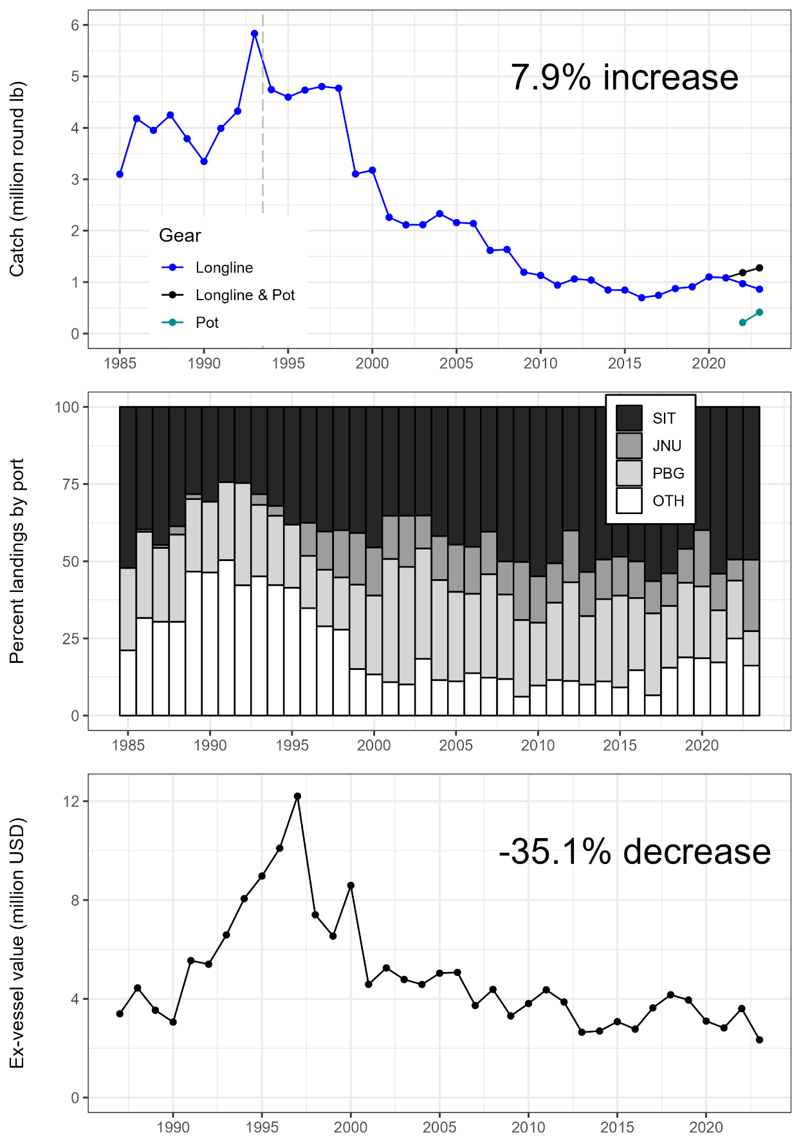

Figure 2.–Catch, landings by port, and ex-vessel value for Northern Southeast Inside (NSEI) Subdistrict commercial sablefish 1985–2023.

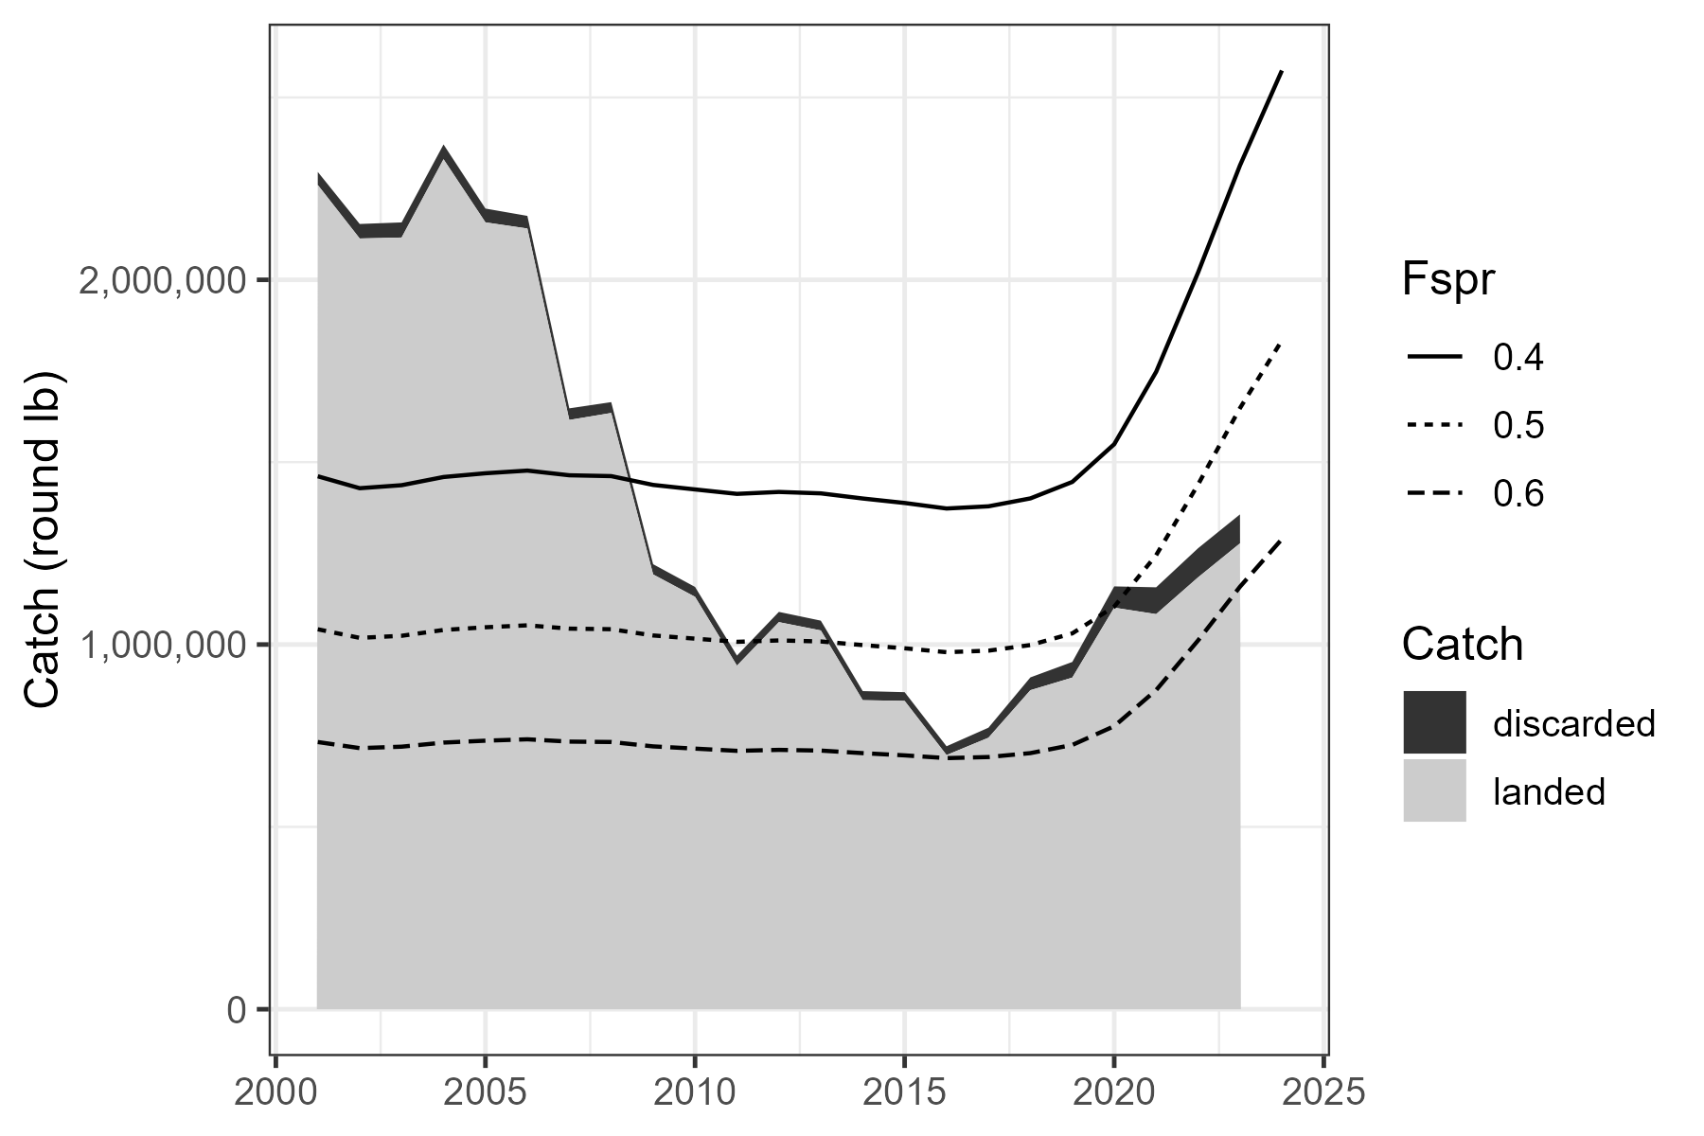

Figure 3.–Estimated catch in the Northern Southeast Inside (NSEI) Subdistrict fishery from 2000–2023 and the relationship to *F40, F50* and *F60* (*Fspr*), the fishing mortality that results in a spawner-per-recruit (SPR) of 40, 50 and 60% of the population’s virgin state in model v23.

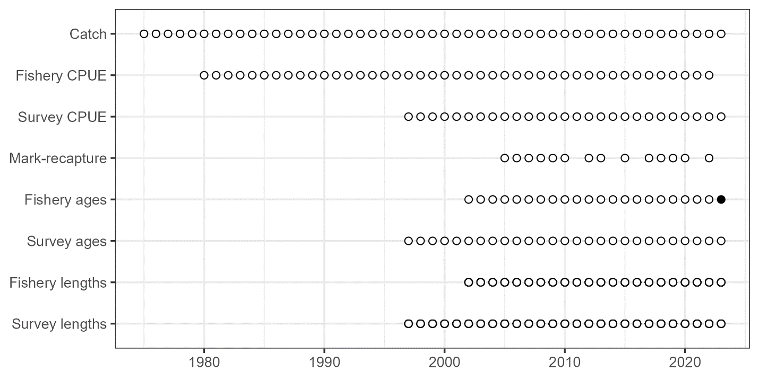

Figure 4.–A summary of the available data sources in the Northern Southeast Inside (NSEI) Subdistrict by year.

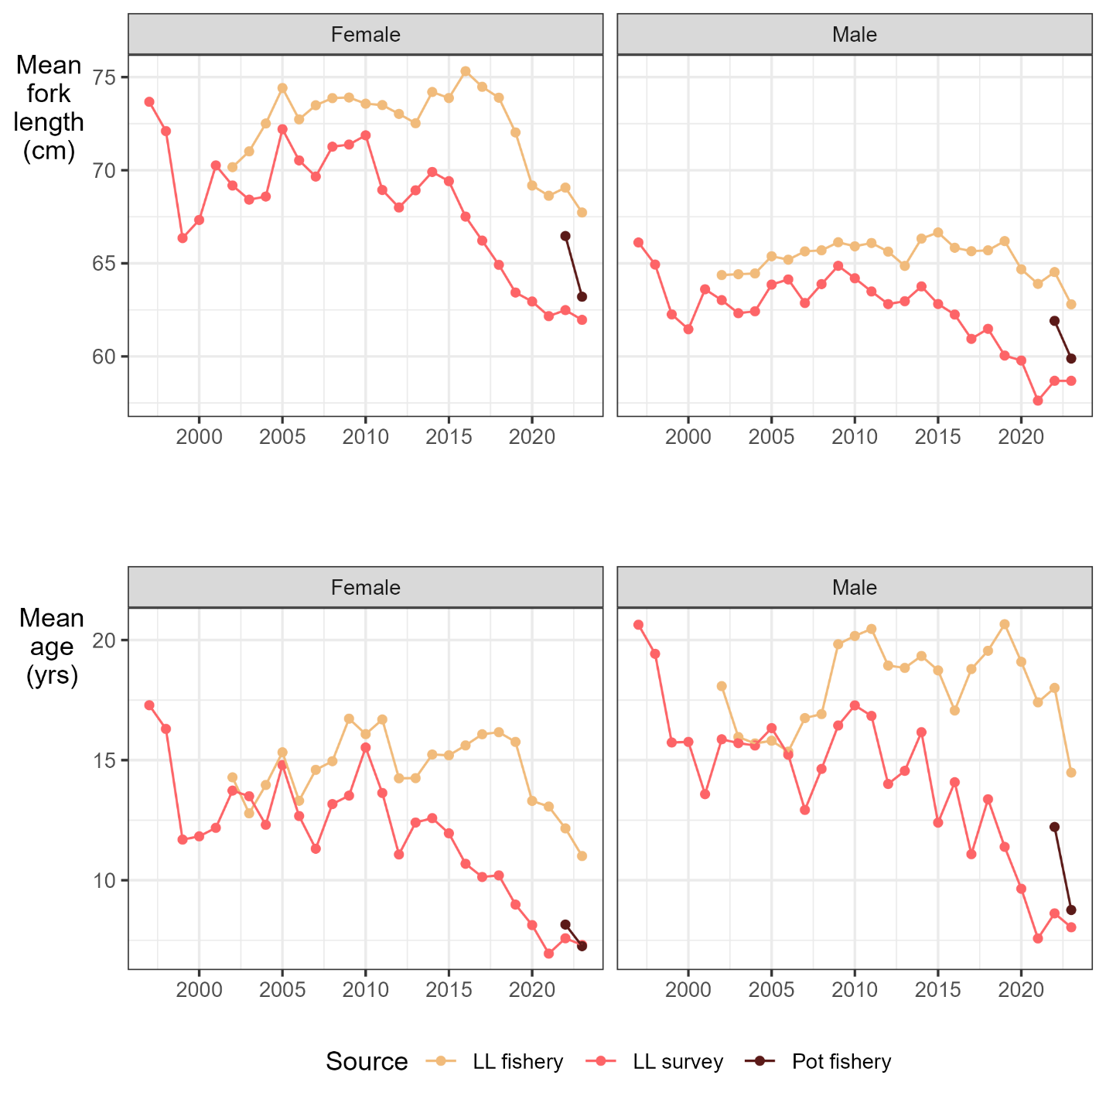

Figure 5.–A comparison of the mean length and age in the longline and pot fishery and longline survey since 1997 for male and female sablefish in the Northern Southeast Inside (NSEI) Subdistrict. The pot fishery is only included for 2022 and 2023 when pot gear became a legal gear type in the fishery.

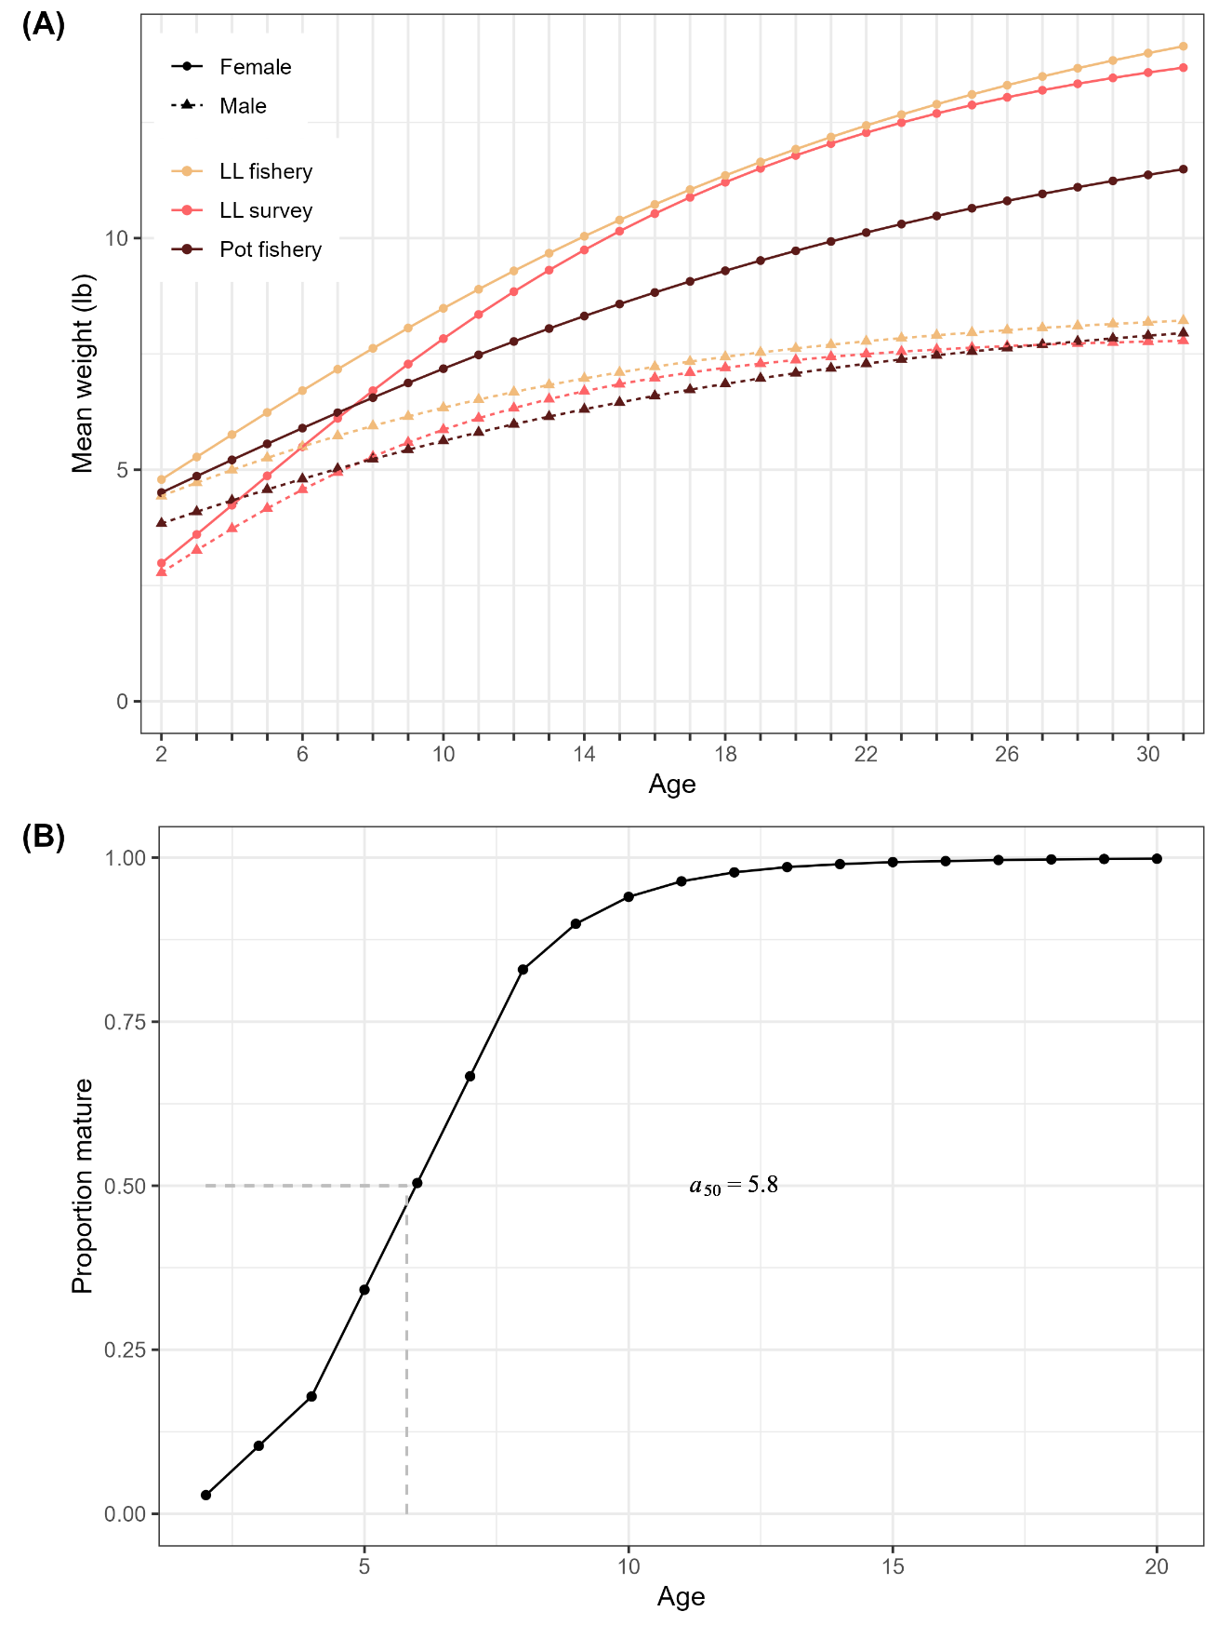

Figure 6.–Biological inputs to the statistical catch-at-age model, including: (A) von Bertalanffy growth model predictions of weight-at-age (kg) by sex from the longline fishery (gold), pot fishery (brown) and ADFG longline survey (red) and (B) proportion mature at age for females estimated from the longline survey with the age at 50% maturity (*a50* = 5.9 yr).

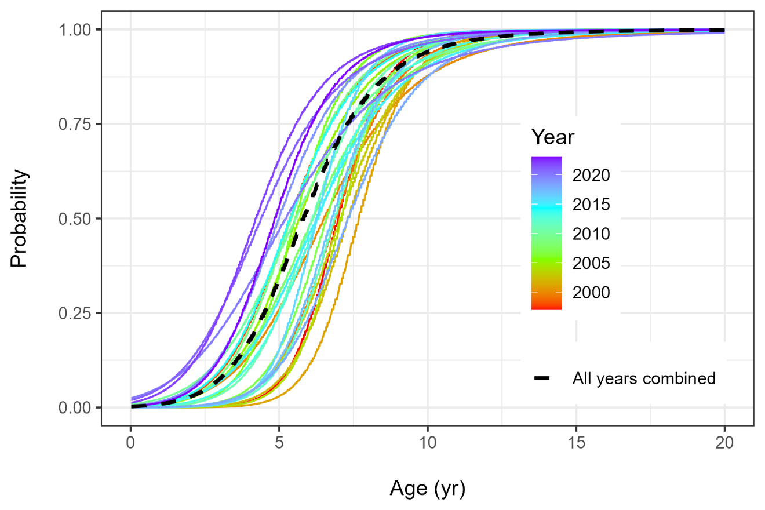 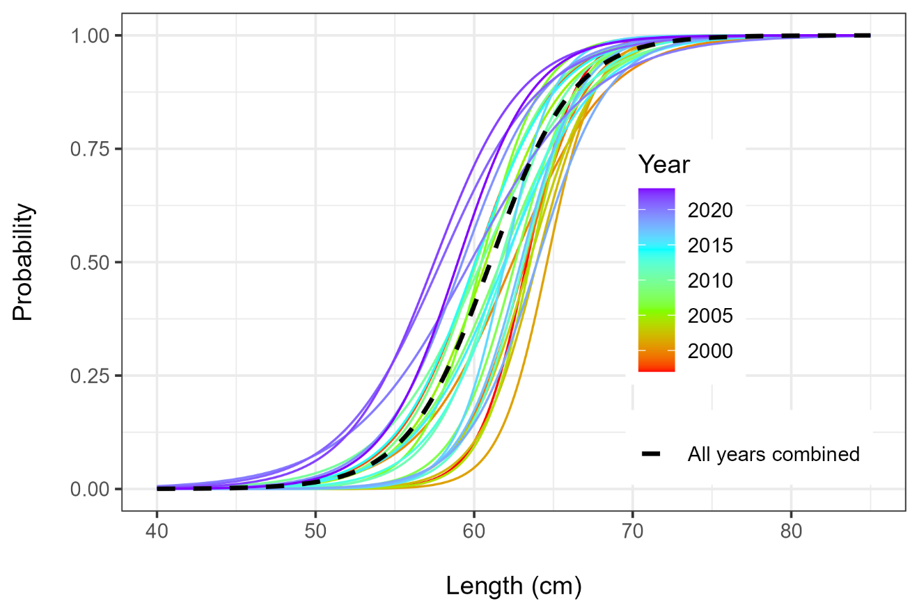

Figure 7.–Changes in maturity-at-age (top panel) and -length (bottom panel) over time in the Northern Southeast Inside (NSEI) Subdistrict sablefish population. There is a general trend of fish maturing at younger ages and smaller sizes. The model uses an average of all years for the assessment.

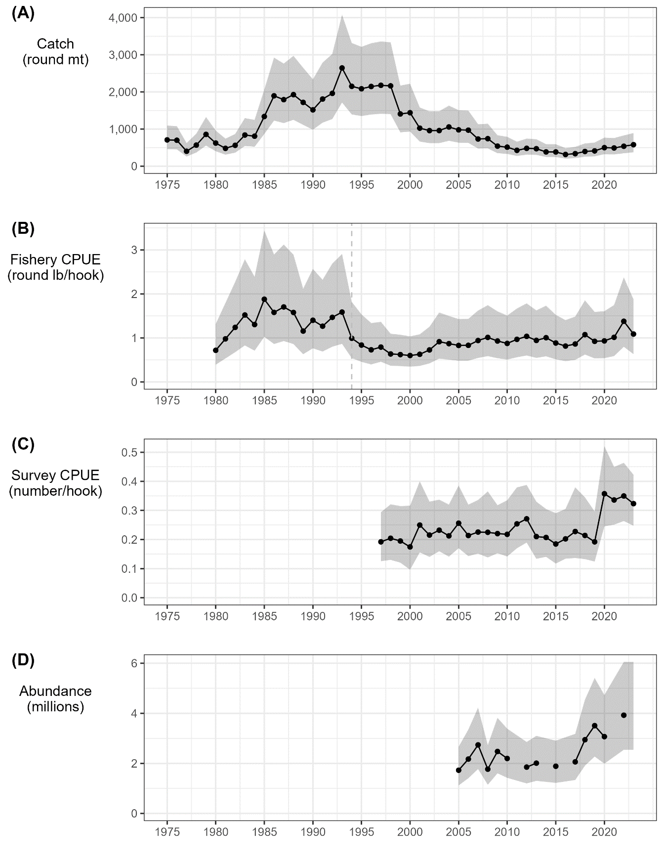

Figure 8.–Indices of catch and abundance with the assumed error distribution, including: (A) harvest (round mt), (B) fishery catch per unit effort in round lb per hook, (C) survey catch per unit effort in number of fish per hook, and (D) mark-recapture abundance estimates in millions. The dashed vertical line in 1994 marks the transition to the Equal Quota Share program.

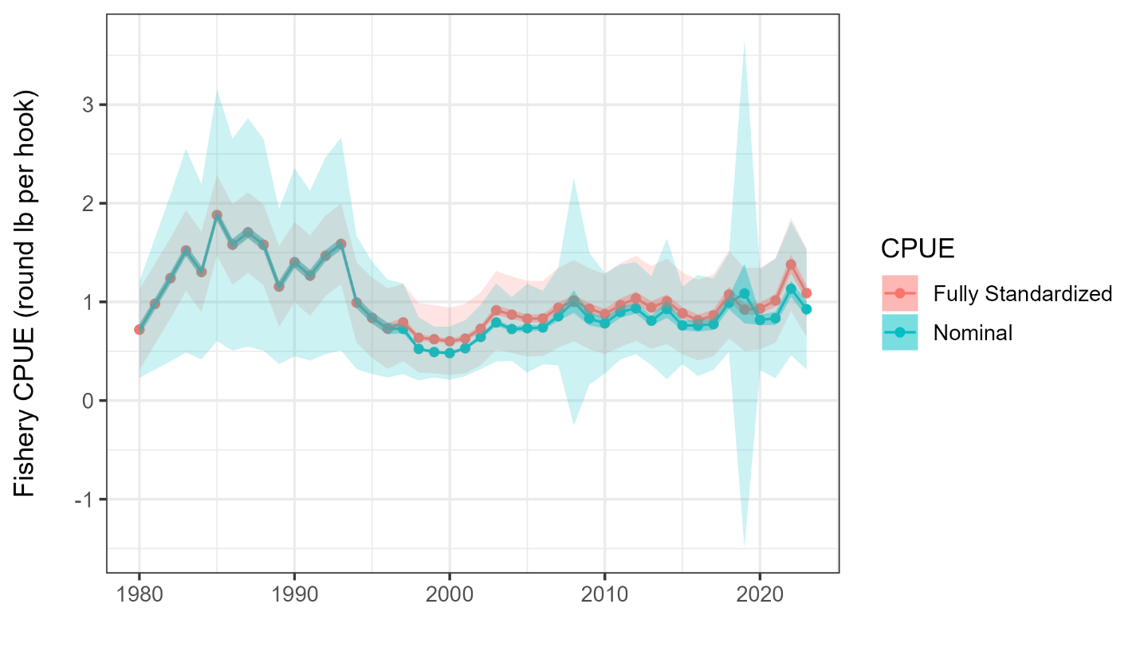

Figure 9.–Catch per unit effort (CPUE) in the Northern Southeast Inside (NSEI) Subdistrict longline sablefish fishery in round lbs per hook. The nominal values (blue) represent values from past assessments and the fully standardized values (red) represent the values used in this assessment.

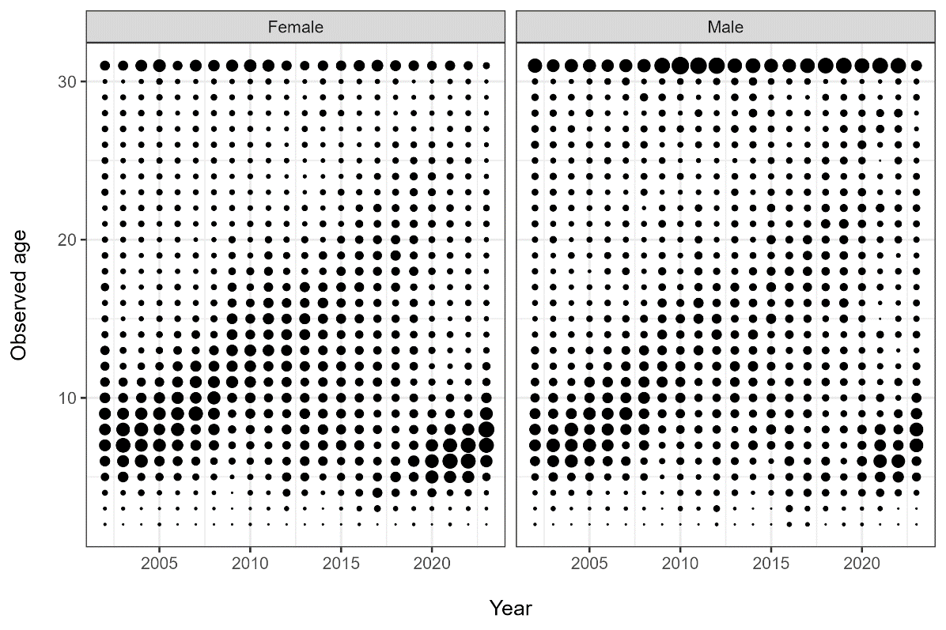

Figure 10.–Proportions-at-age by sex for the Northern Southeast Inside (NSEI) Subdistrict longline fishery (2002–2023, Top row) and ADFG longline survey (1997–2023, bottom row).

1

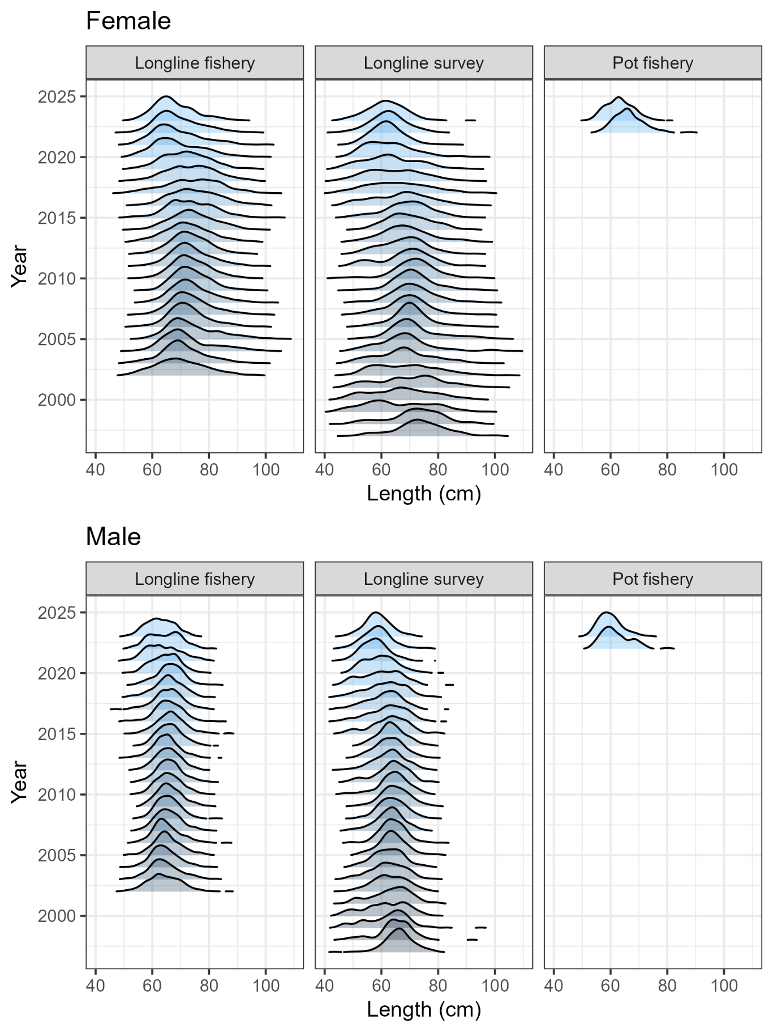

Figure 12.–Longline fishery, pot fishery and survey length distributions by sex from 1997–2023.

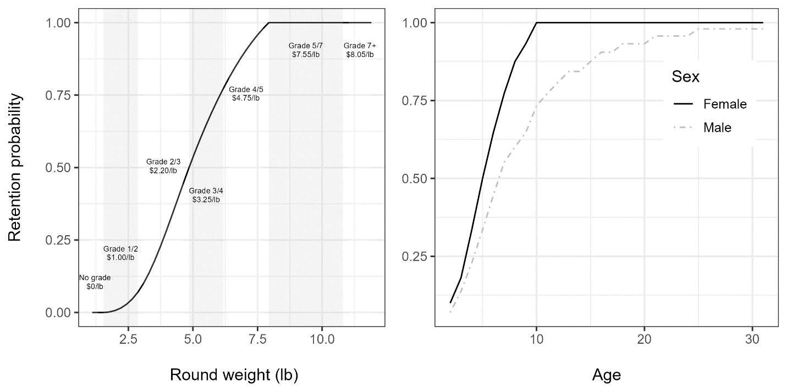

Figure 13.–The probability of retaining a fish as a function of weight (left), sex, and age (right).

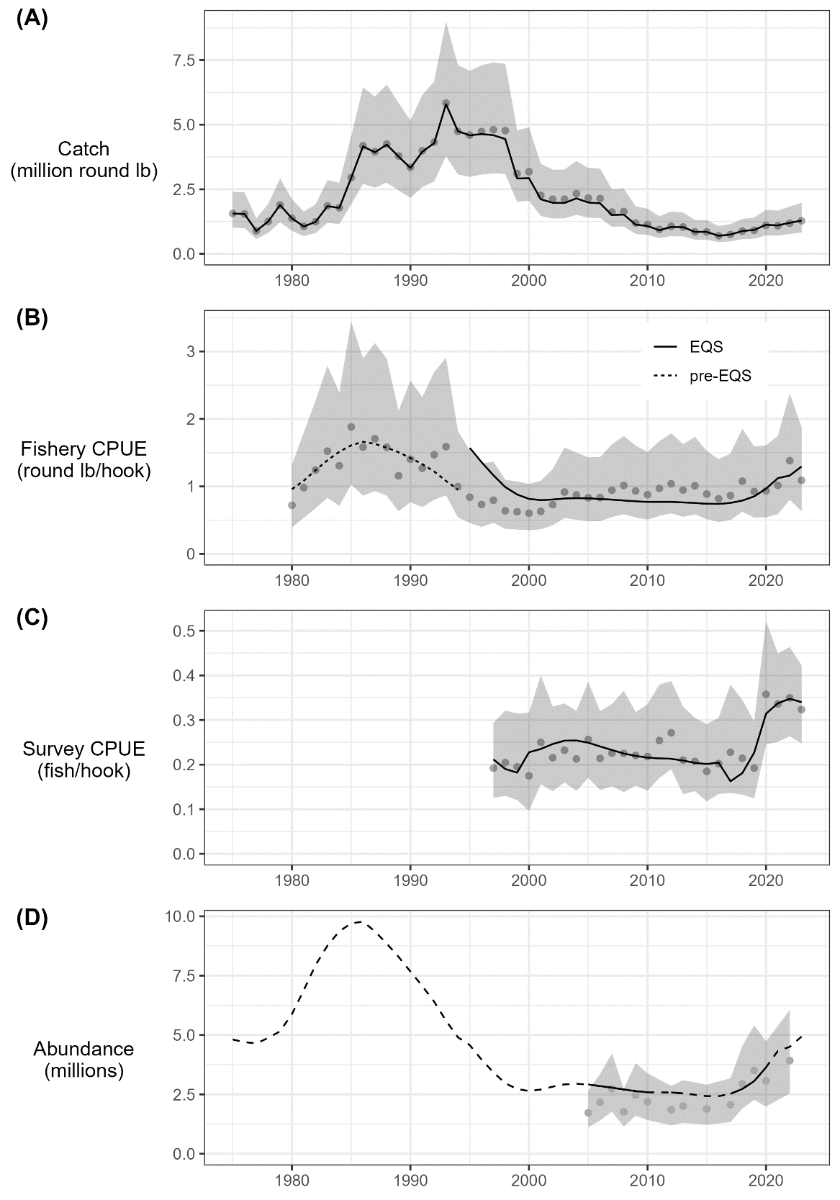

Figure 14.–Fits to indices of catch and abundance with the assumed error distribution shown as shaded grey polygons. Input data are shown as grey points and model fits are shown in black. Indices include (A) harvest (million round pounds); (B) fishery catch per unit effort in round pounds per hook with separate selectivity and catchability time periods before and after the implementation of the Equal Quota Share (EQS) program in 1994; (C) survey catch per unit effort in number of fish per hook; and (D) mark-recapture abundance estimates in millions. Solid and dashed-lines in panel D reflect years for which data were and were not available, respectively.

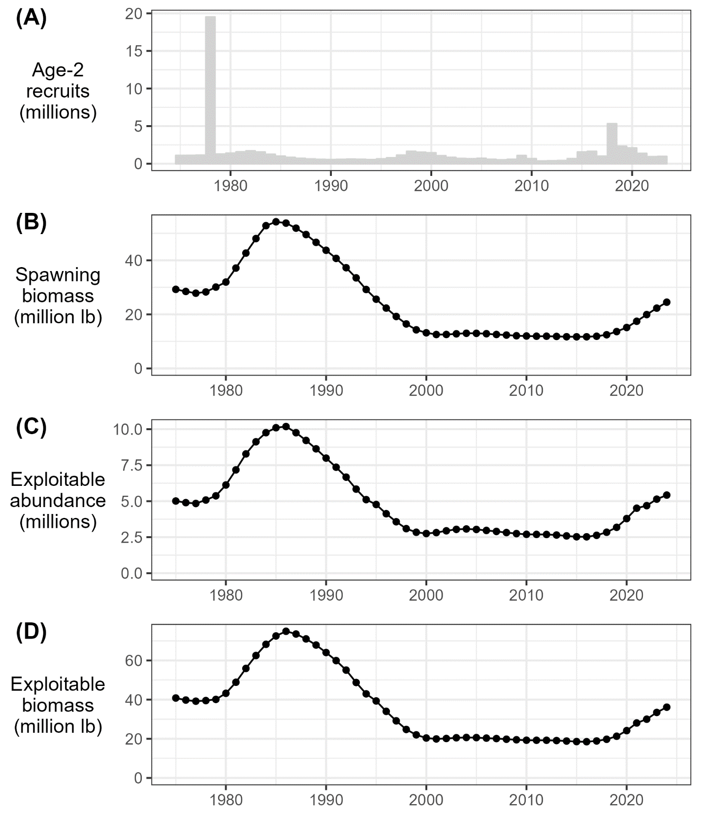

Figure 15.–Model predictions of (A) age-2 recruitment (millions); (B) female spawning stock biomass (million pounds); (C) exploitable abundance (millions); and (D) exploitable biomass (million pounds).

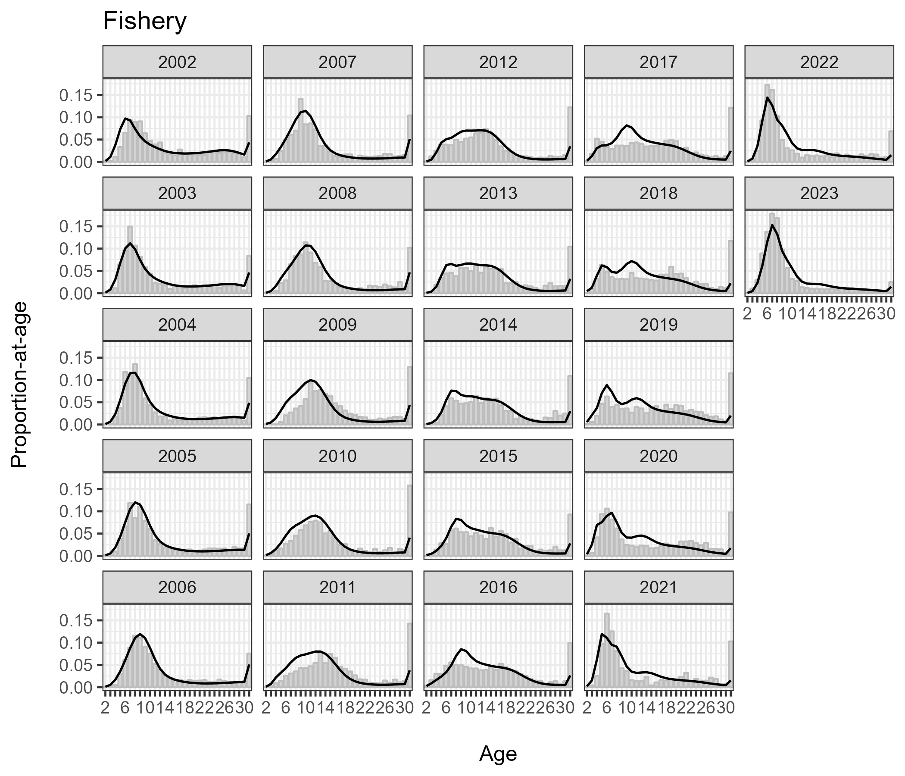

Figure 16.–Fits to fishery age compositions, 2002–2023. Observed and predicted proportions-at-age shown as grey bars and black lines, respectively.

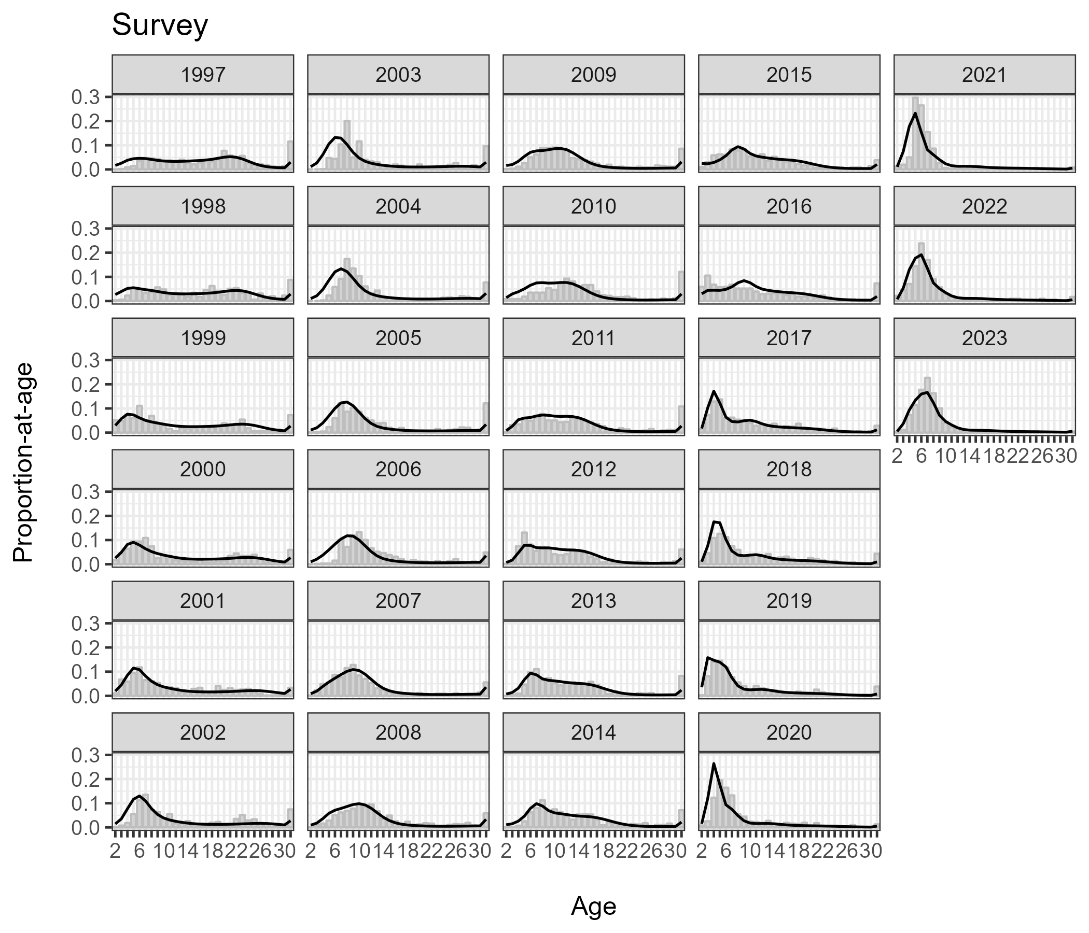

Figure 17.–Fits to survey age compositions, 1997–2023. Observed and predicted proportions-at-age shown as grey bars and black lines, respectively.

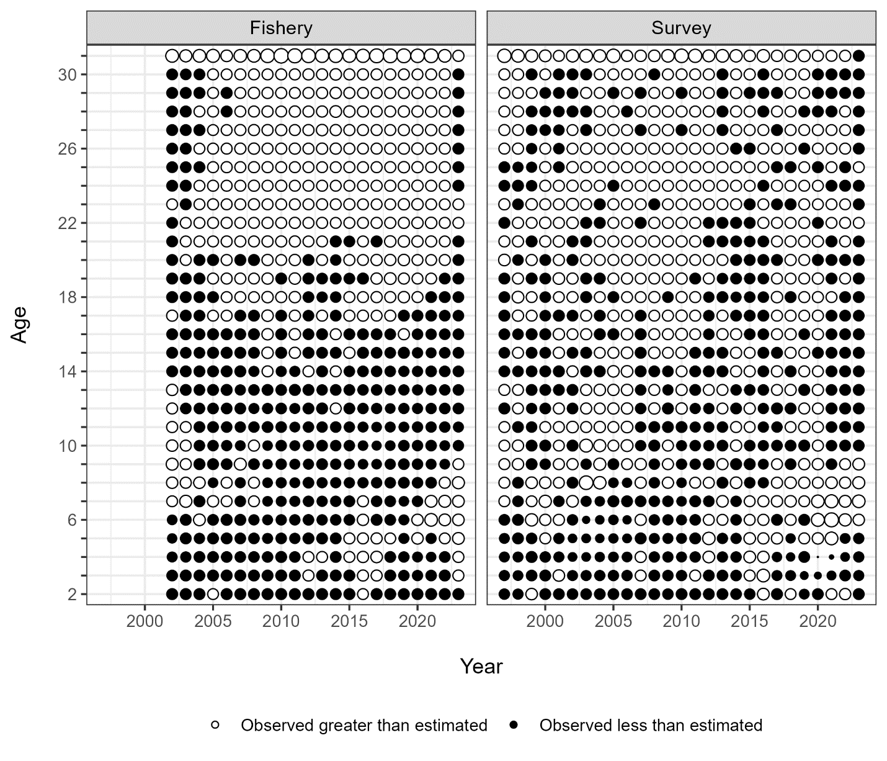

Figure 18.–Standardized residuals of fits to fishery (2002–2023) and survey (1997–2023) age compositions. Size of residual scales to point size. Black points represent negative residuals (observed < predicted); white points represent positive residuals (observed > predicted).

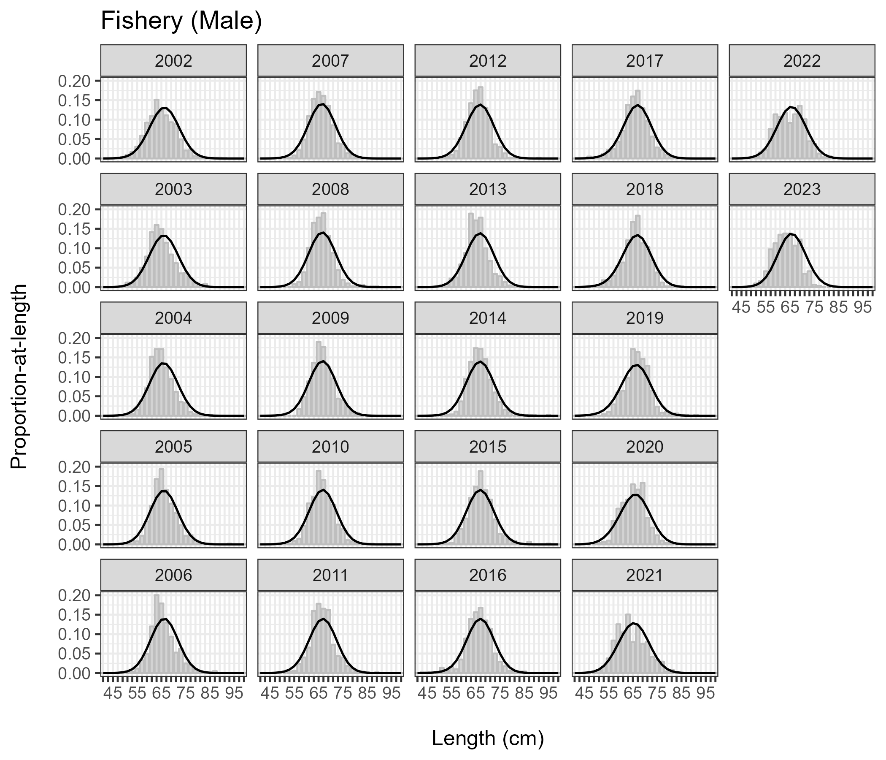

Figure 19.–Fits to male fishery length compositions, 2002–2023. Observed and predicted proportions-at-age shown as grey bars and black lines, respectively.

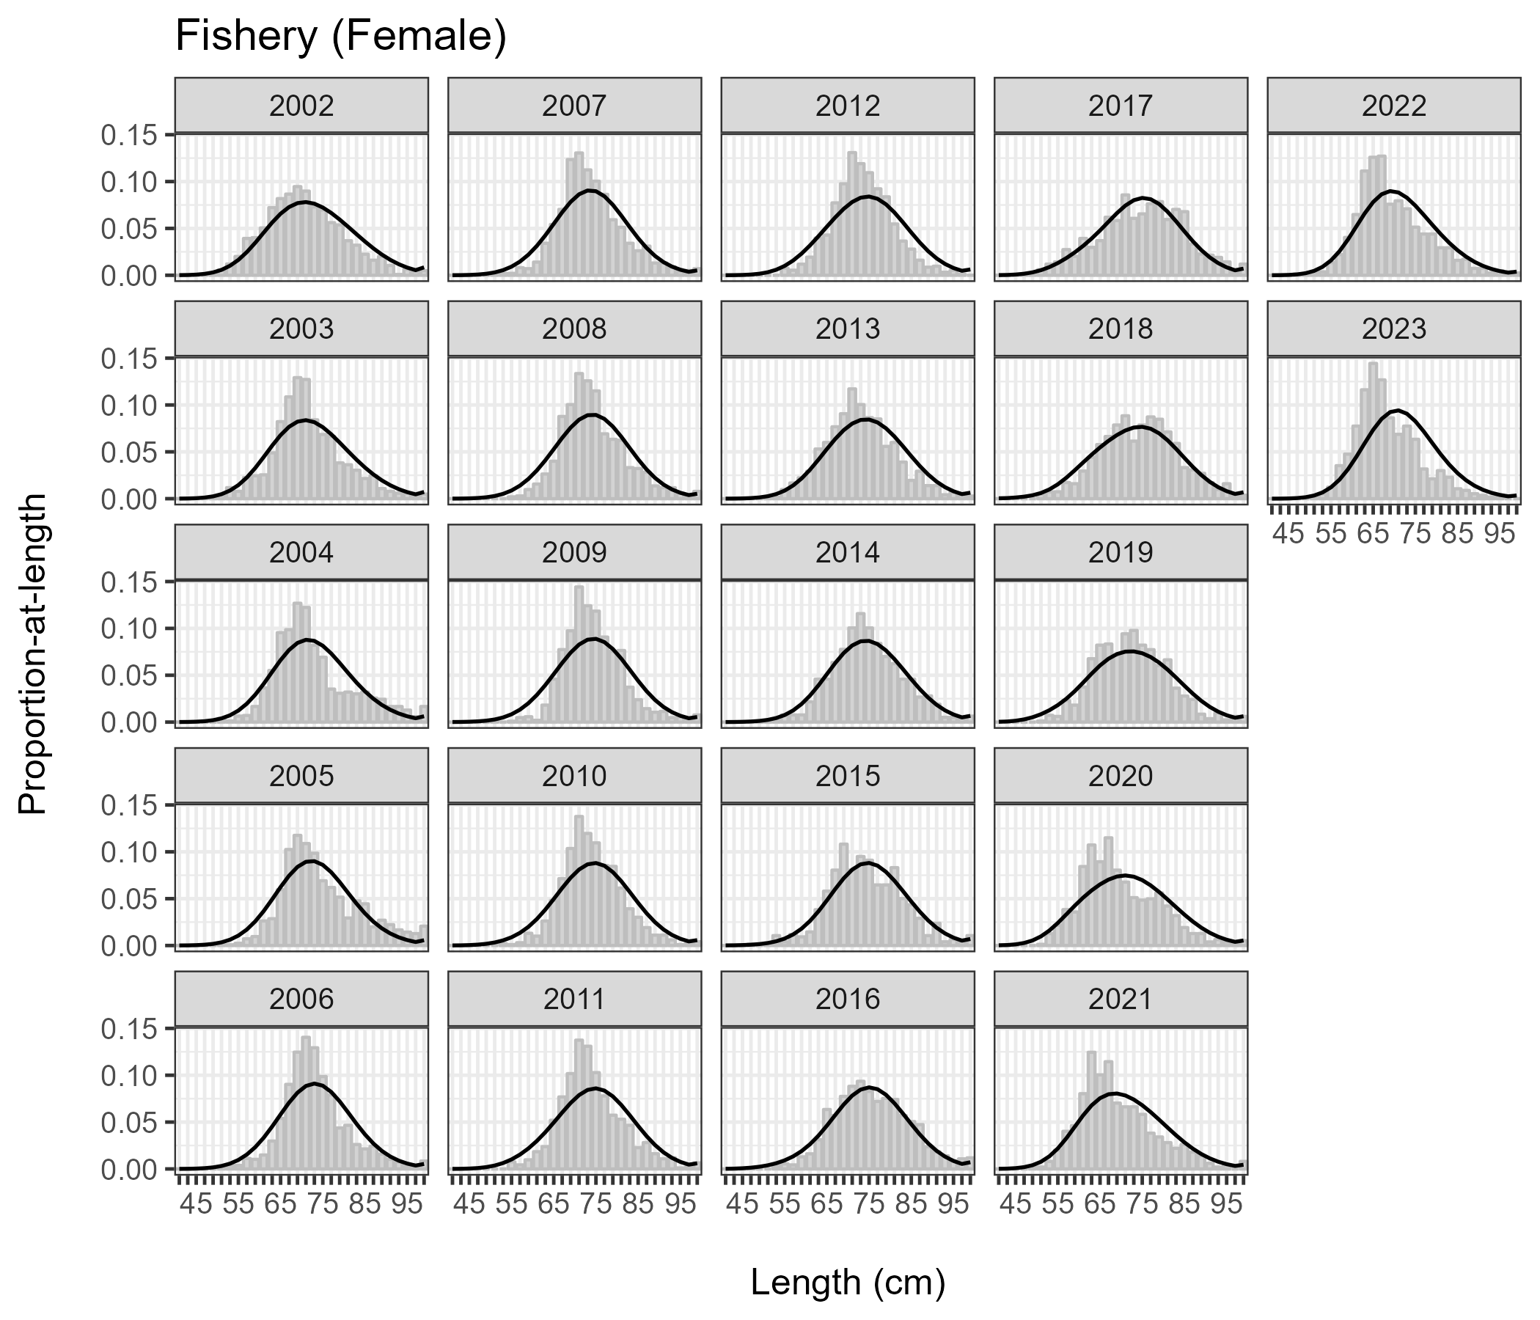

Figure 20.–Fits to female fishery length compositions, 2002–2023. Observed and predicted proportions-at-age shown as grey bars and black lines, respectively.

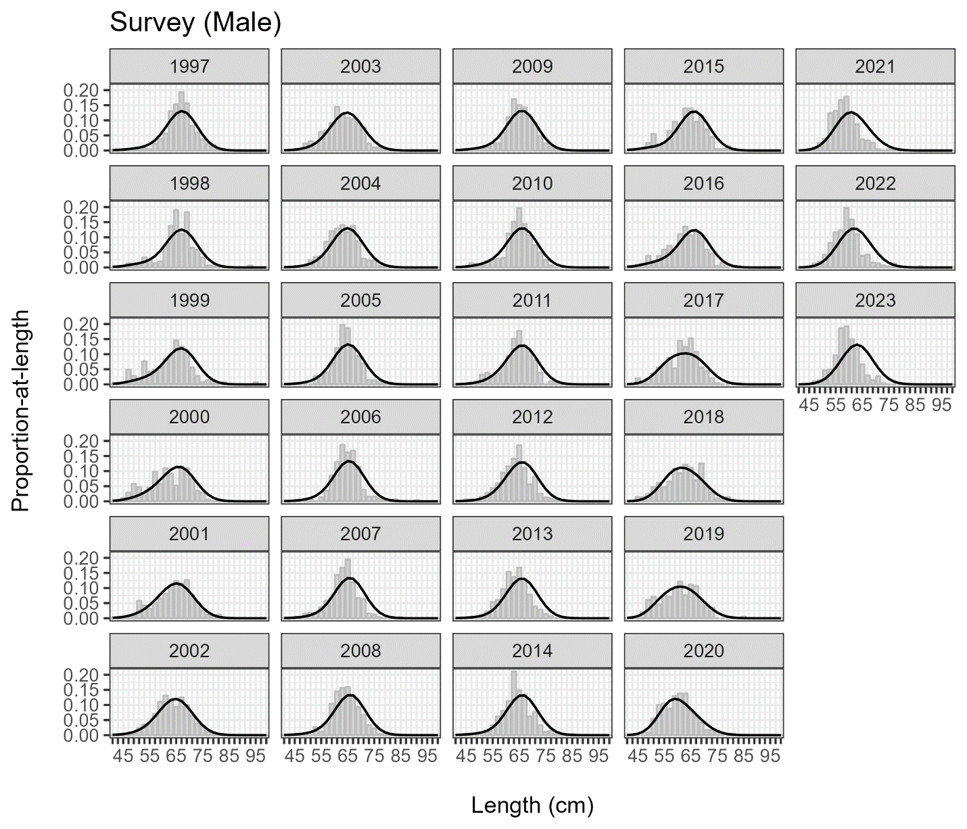

Figure 21.–Fits to male survey length compositions, 1997–2023. Observed and predicted proportions-at-age shown as grey bars and black lines, respectively.

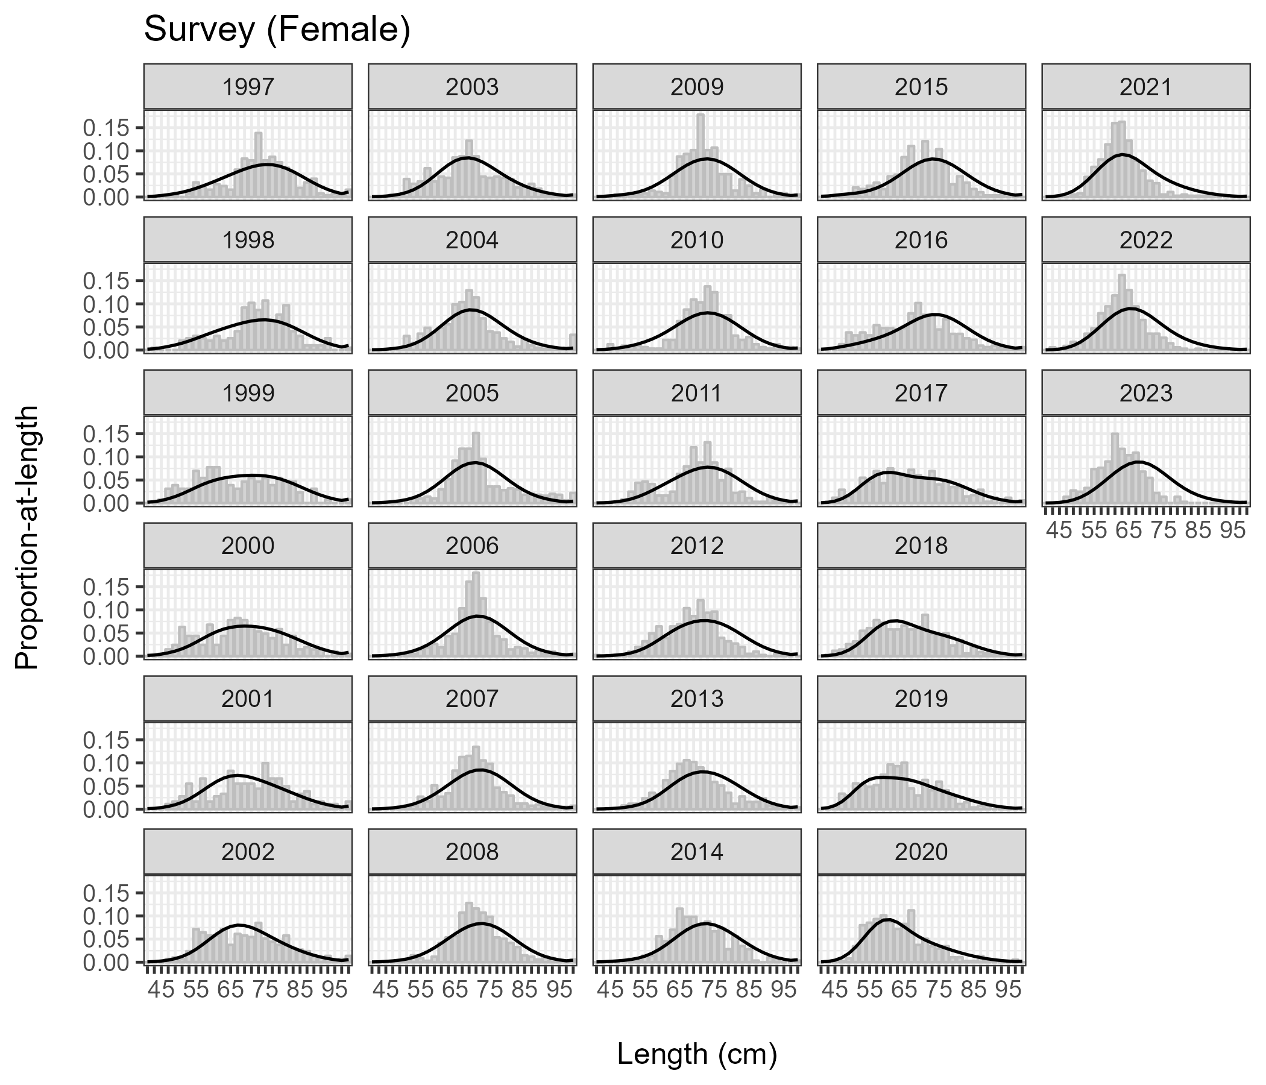

Figure 22.–Fits to female survey length compositions, 1997–2023. Observed and predicted proportions-at-age shown as grey bars and black lines, respectively.

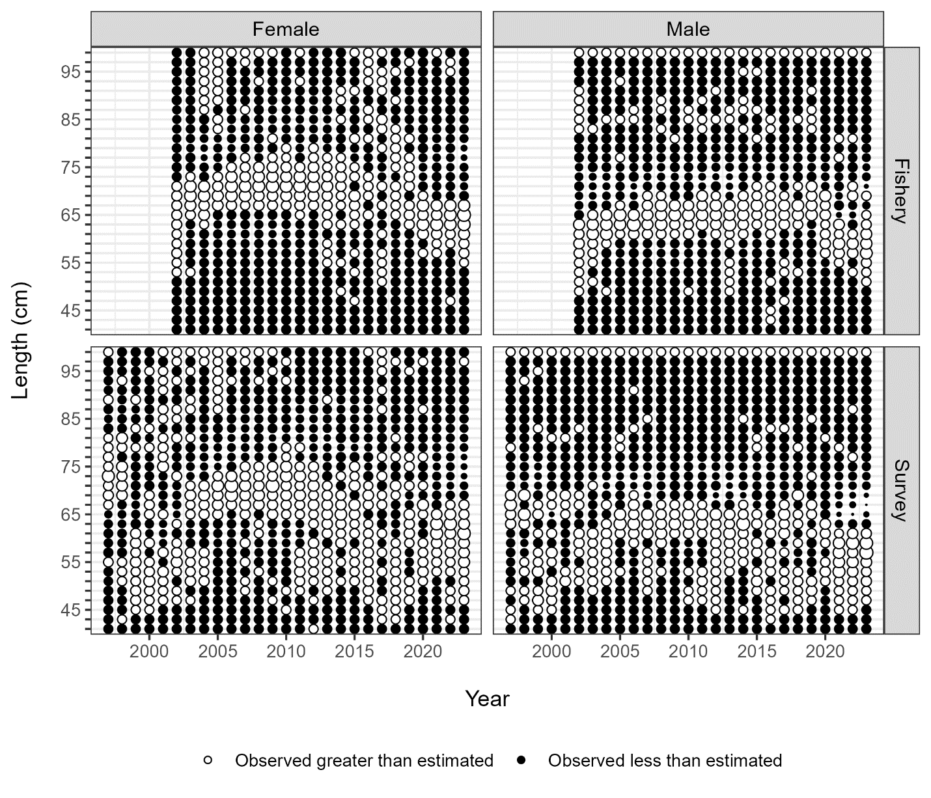

Figure 23.–Standardized residuals of fits to fishery (2002–2022) and survey (1997–2022) length compositions for males and females. Size of residual scales to point size. Black points represent negative residuals (observed < predicted); white points represent positive residuals (observed > predicted).

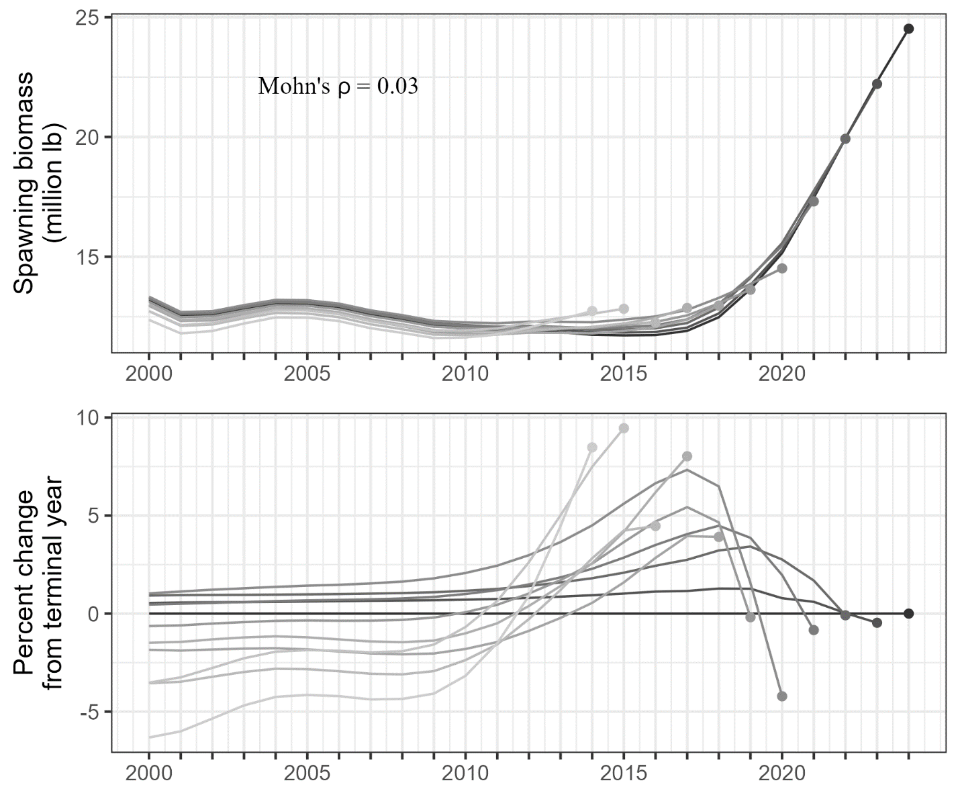

Figure 24.–Mohn’s r and retrospective peels of sablefish spawning biomass.

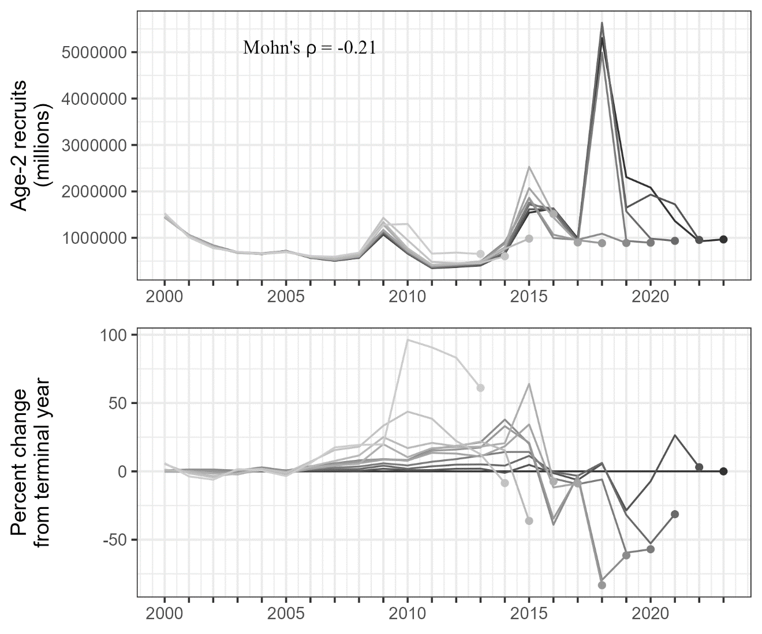

Figure 25.–Mohn’s r and retrospective peels of sablefish recruitment for the last nine years.

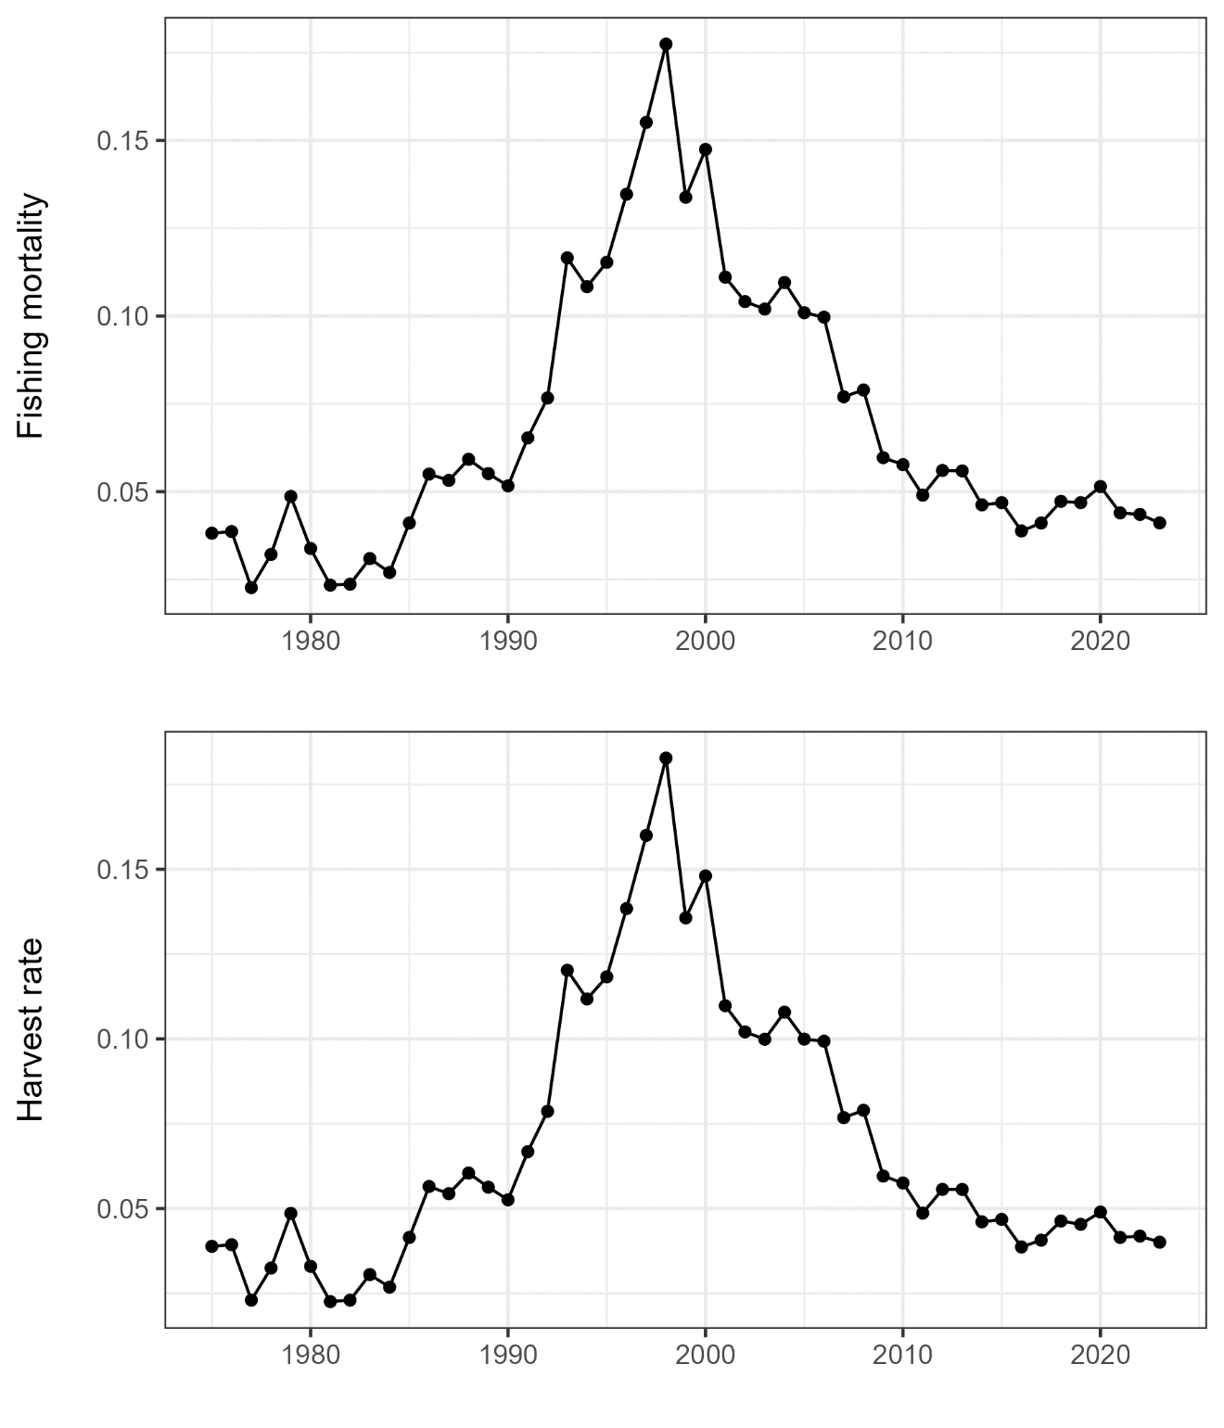

Figure 26.–Model-estimated fishing mortality rate (top) and realized harvest rate (bottom), defined as the ratio of total predicted catch to exploitable biomass. Total predicted catch is the sum of landed catch and discarded biomass assumed to die post-release.